## Experiment 1

**Computer Communications**

**Name: DEBASYA SAHOO**

**Faculty: Prof. Berlin Hency**

**Slot:L49+L50**

**Registration Number: 15BEC1111**

**Aim:**

1. Simulation of client server network topology using cisco packet tracer

**Software used:** Cisco Packet Tracer

## Simulation and outputs:

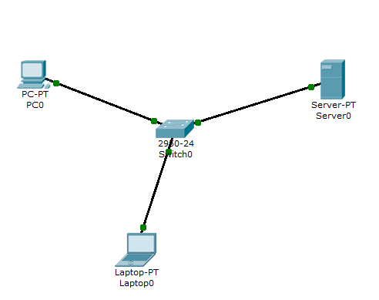

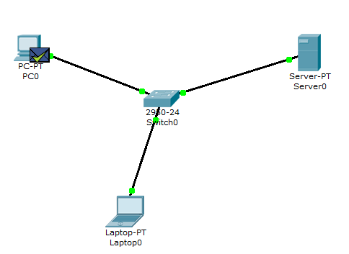

### Each pc, laptop, switch and the server are given different IP addresses and are connected using copper wire.

**Pinging to check connectivity**:

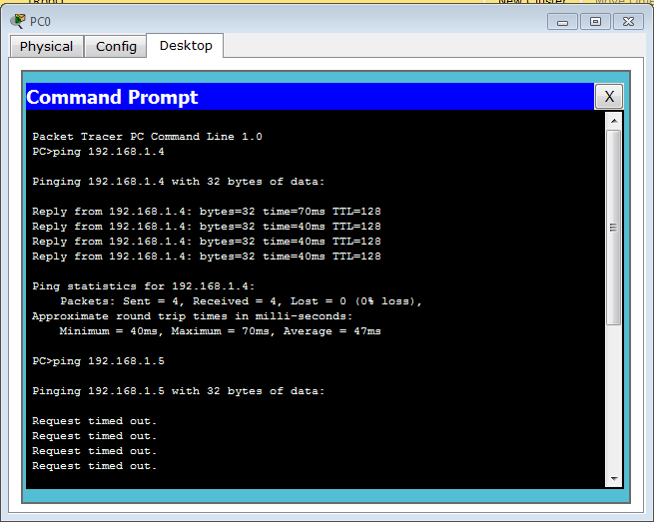

**ipconfig:**

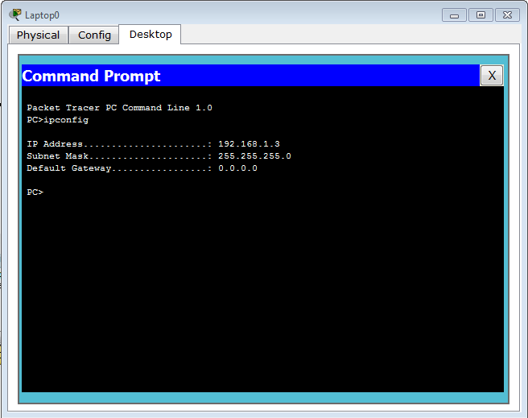

**Enabling the DNS Service:**

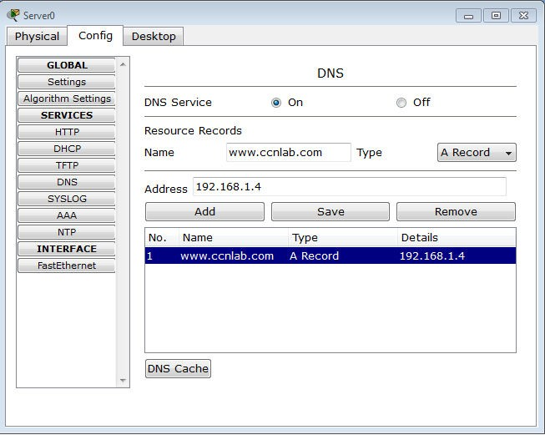

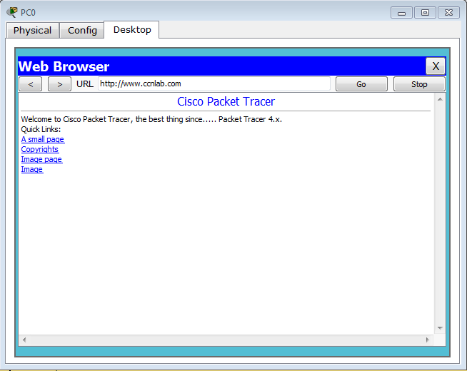

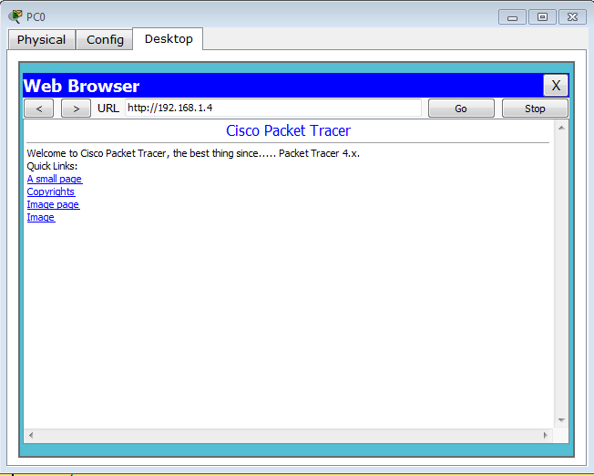

After enabling the DNS service we gave a name to the server’s IP address, ‘[*www.ccnlab.com*](http://www.ccnlab.com/)*’* after which we could access it by using the domain name in the web browser.

**getmaccommand:**

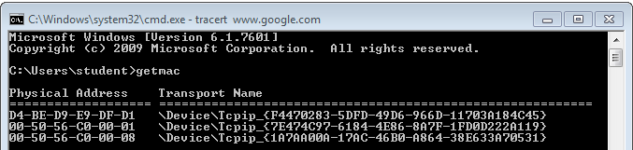

**Trace route command:**

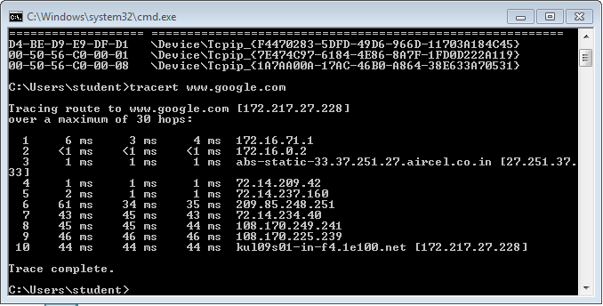

**Name Service lookup:**

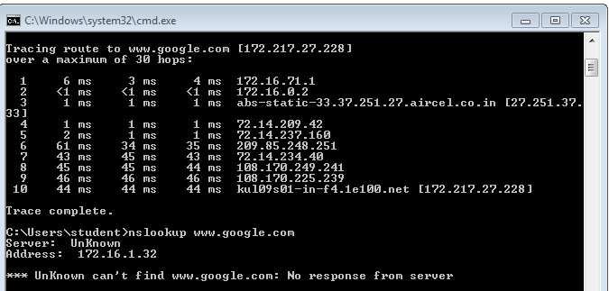

**ns look up *domain_name*** shows us the server name and displays one of the addresses.

***Inferences:***

### IP address is 32 bits in size.

* + **‘ping *destination_address*’**is used to verify IP-level connectivity. It sends few packets of data and then receives the packets back(ACK messages) then compares the number of packets sent and number of packets received to determine the lost packets (% loss).
  + **Round Trip Time (RTT)** is the amount of time it takes to send a signal and receive acknowledgement of that signal.
  + **‘ipconfig’** displays IP address, Subnet Mask and Default Gateway for that device.
  + **ICMP** - **Internet Control Message Protocol**. This protocol is used by *ping*.
  + **DNS - Domain Name Server**. They maintain a directory of domain names and translate them to IP addresses.
  + **HTTP(S) – Hypertext Transfer Protocol (Secure).** HTTP the foundation of data communication for the world wide web.
  + **‘nslookup’ – Name Service look up**is used for querying the DNS and the IP address.

### **‘getmac’** – **get Medium Access Control**, gives the MAC address. It is a physical address of the device which cannot be changed. It is 48 bits address represented in hexadecimal format.

* + **‘tracert*domain_name(destination)*’** – Trace route, is used to show several details about the path that a packet takes from the computer or device you're on to whatever destination you specify.This tracert option specifies the maximum number of hops in the search for the *target*. If you do not

specify *MaxHops*, and a *target* has not been found by 30 hops, tracert will stop looking.

#### Experiment 2

**Name: Debasya Sahoo**

**Registration number: 15BEC1111**

**Aim:**

* + - **Study of TCL (Tool Command Language).**
    - **Simulation and analysis of point to point wired network using NS2 Software: linux cmd prompt**

**List of cmds:**

* + - **pwd: present working directory**
    - **ls: listing**
    - **ls -l : long listing format**

***presence of d->directory, - -> files***

* + - **ls -ltr : long listing sorting in time reverse order**
    - **clear: clear screen**
    - **mkdir: make new directory**
    - **cd: change directory**
    - **cd .. : take to previous directory**
    - **cd ~ : go to home directory**
    - **gedit: graphic editor**
    - **gedit test.txt & : separate process**
    - **grep “hello” test1.txt : to find number of occurrence (case sensitive)**
    - **grep -i “hello” test.txt: to find number of occurrence (case insensitive)**
    - **grep -i “hello” test.txt | wc -l : word cound**
    - **cp test.txt test1.txt : copy from one file to another**
    - **cat test.txt : contents displayed in terminal**
    - **ls D* : list all files starting with D**

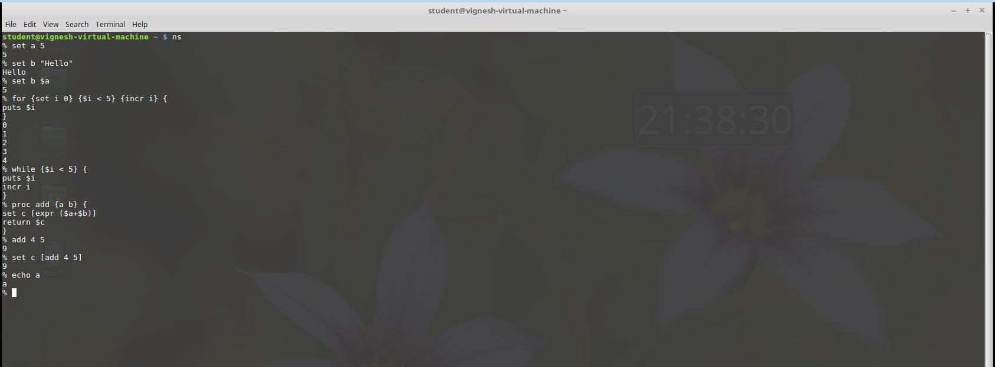

**Aim: Simulation and analysis of point to point wired network using NS2 Software used: NS2**

**Description:**

* + - First create a new directory.
    - Go to that directory and create a file sample2.tcl
    - Open the file and write the tcl script.
    - Save and compile and run the tcl script.

#### Code:

**#Create an intance of Simulator class**

set ns [new Simulator]

#### #Create a Trace file

set tf [open sample.tr w]

$ns trace-all $tf

#### #Create a NAM file

set nf [open sample2.nam w]

$ns namtrace-all $nf

#### #Create nodes and duplex links

set n0 [$ns node] set n1 [$ns node]

#### # Create duplex link between source and target of 1Mb BW, 10ms propagation delay and DropTail queueing mechanism

$ns duplex-link $n0 $n1 1Mb 10ms DropTail

#### # Create Transport Agents

**#Create UDP object**

set udp0 [new Agent/UDP]

#### #Attach the UDP object to $n0

$ns attach-agent $n0 $udp0

#### #Create a NULL object

set null0 [new Agent/Null]

#### #Attach the NULL object to $n0

$ns attach-agent $n1 $null0

#### # Generate Application Traffic

**# Constant Bit Rate Application (CBR)**

set cbr0 [new Application/Traffic/CBR]

$cbr0 set packetSize_ 500

$cbr0 set interval_ 0.005

$cbr0 attach-agent $udp0

#### #Virtually connect these 2 agents

$ns connect $udp0 $null0

**#Finish Procedure** proc finish {} { global ns nf tf

#### # flush-trace: Dumps all content to trace and nam file

$ns flush-trace close $tf

close $nf

exec nam sample2.nam & exit 0

}

$ns at 0.5 "$cbr0 start"

$ns at 4.5 "$cbr0 stop"

$ns at 5.0 "finish"

$ns run

#### Output:

**NS2 simulation of point to point wired network**

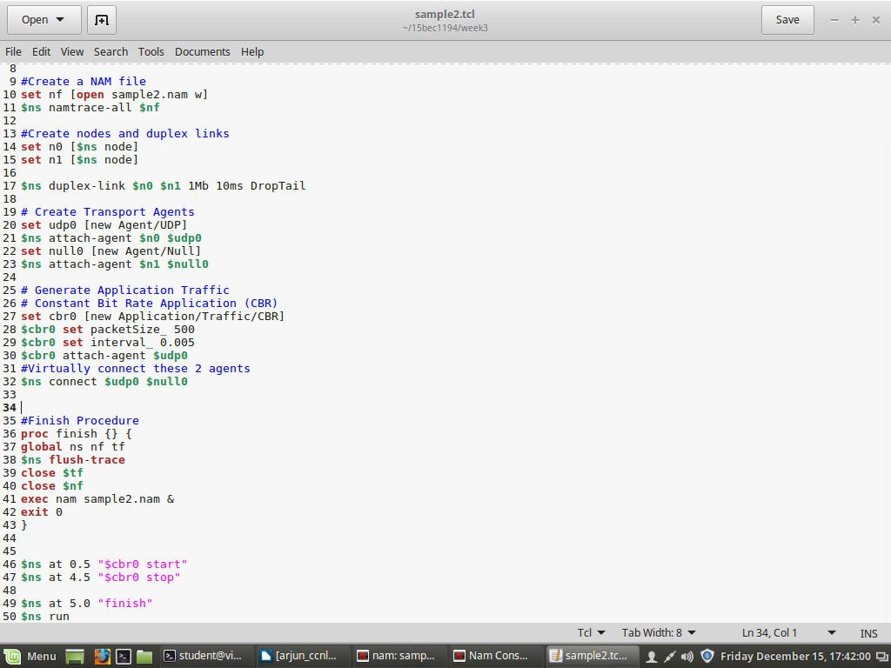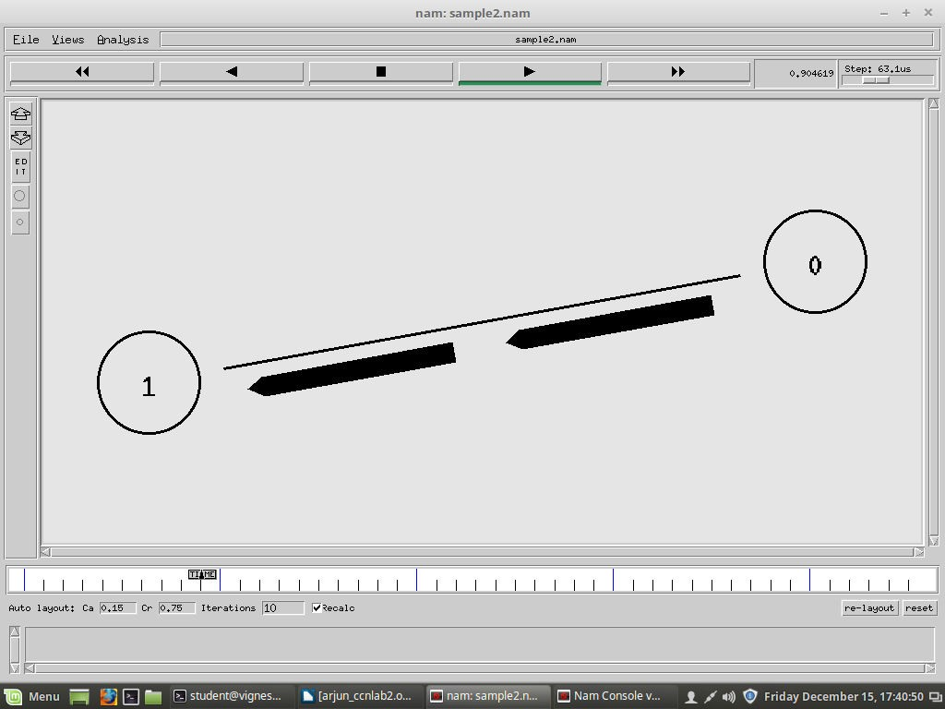

**In trace graph we can observe avg end to end delay, PDR and another node information.**

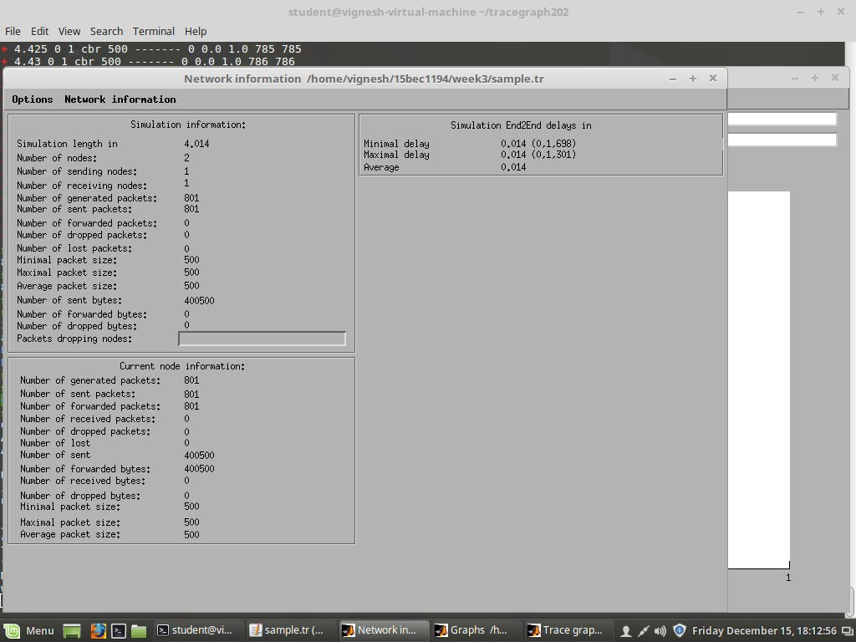

**Network info of source node. Current node information of source node. We observe no packets are lost as link capacity is capable of servicing all the packets.**

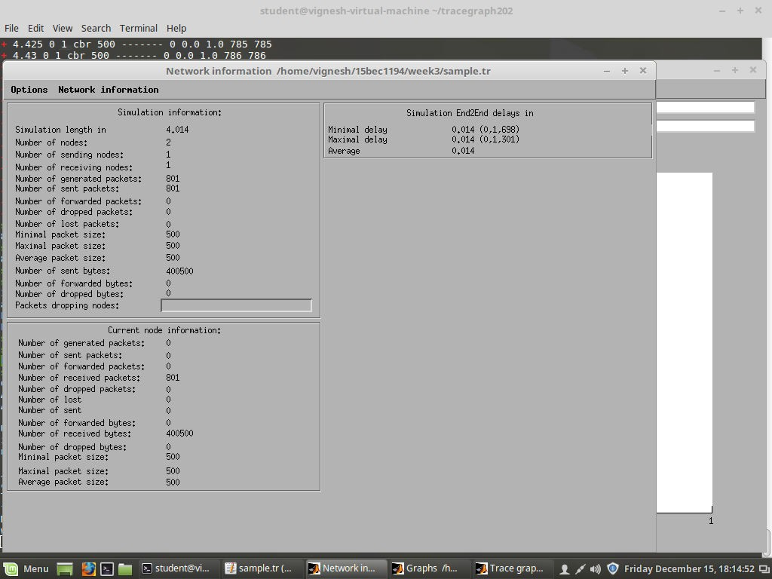

**Current node info of destination**

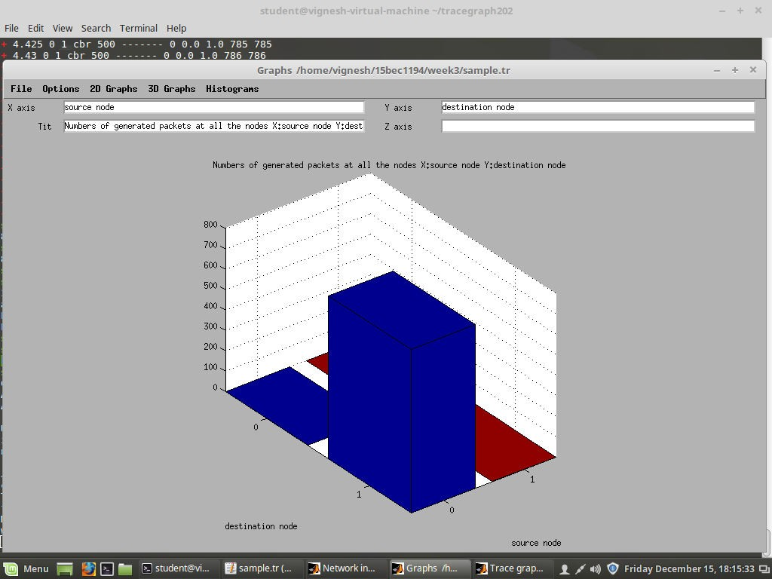

**3-D graph of number of packets generated at all nodes.**

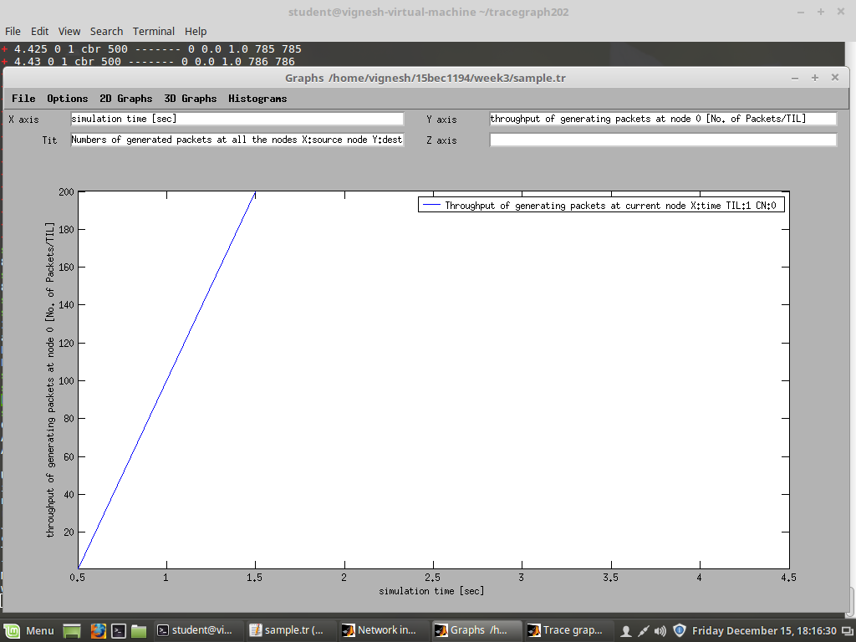

**Throughput of source node.**

***We changed interval to 2ms, we get:***

**Code:**

**#Create an intance of Simulator class**

set ns [new Simulator]

#### #Create a Trace file

set tf [open sample.tr w]

$ns trace-all $tf

#### #Create a NAM file

set nf [open sample2.nam w]

$ns namtrace-all $nf

#### #Create nodes and duplex links

set n0 [$ns node] set n1 [$ns node]

$ns duplex-link $n0 $n1 1Mb 10ms DropTail

#### # Create Transport Agents

set udp0 [new Agent/UDP]

$ns attach-agent $n0 $udp0 set null0 [new Agent/Null]

$ns attach-agent $n1 $null0

#### # Generate Application Traffic

**# Constant Bit Rate Application (CBR)**

set cbr0 [new Application/Traffic/CBR]

$cbr0 set packetSize_ 500

$cbr0 set interval_ 0.002

$cbr0 attach-agent $udp0

#### #Virtually connect these 2 agents

$ns connect $udp0 $null0

**#Finish Procedure** proc finish {} { global ns nf tf

$ns flush-trace close $tf

close $nf

exec nam sample2.nam & exit 0

}

$ns at 0.5 "$cbr0 start"

$ns at 4.5 "$cbr0 stop"

$ns at 5.0 "finish"

$ns run

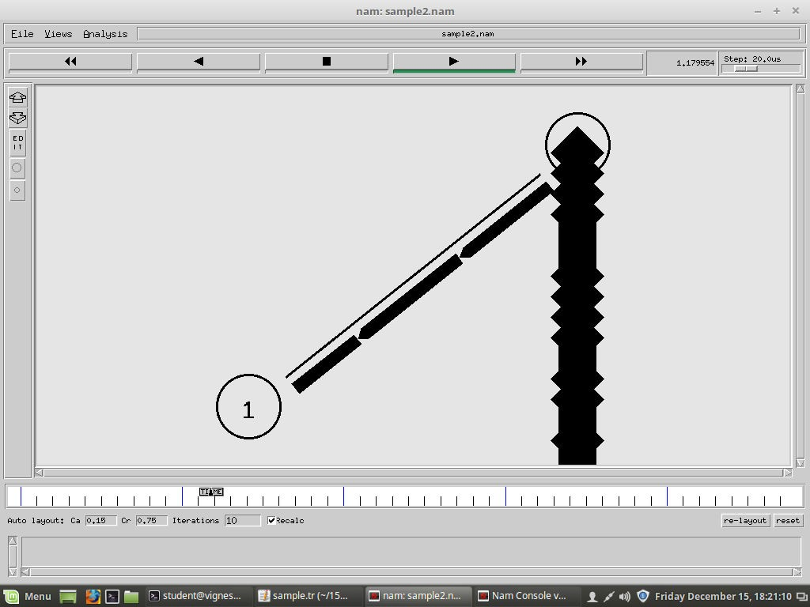

#### We observe that there are dropped packets involved. This is because our link capacity is 1Mbps, but we have set out time interval of packets as 2ms and packet size is 500 bytes. Thus 500*1/0.002*8=2Mbps. As we can see that our link capacity is less than that of packet delivery rate, some of the packets get dropped.

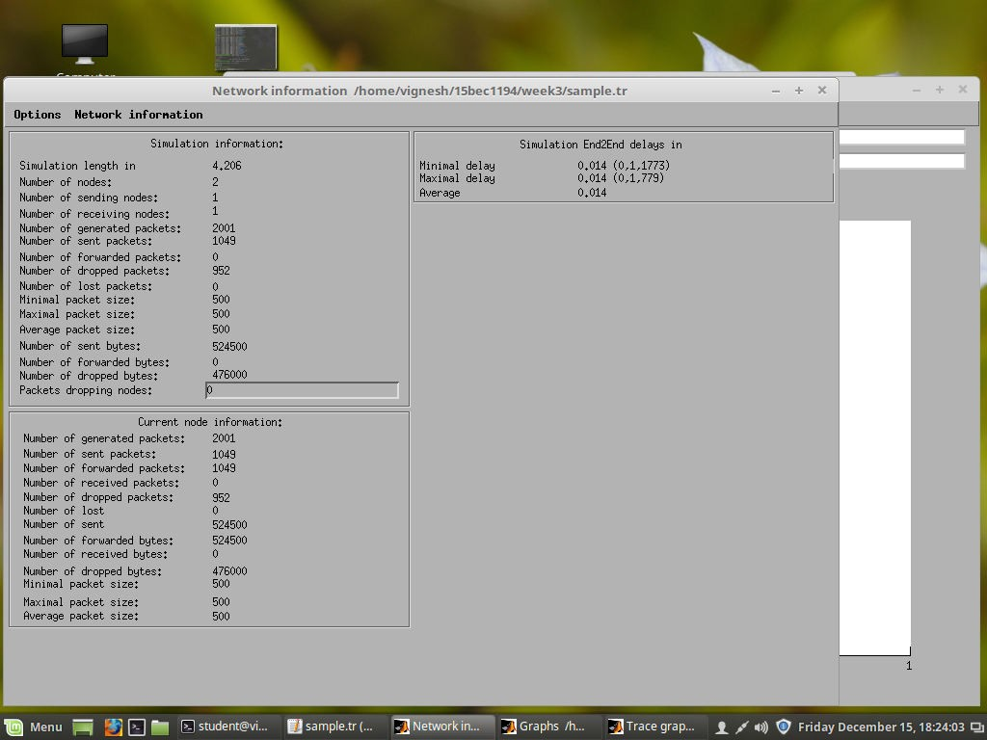

**Network info of source node.**

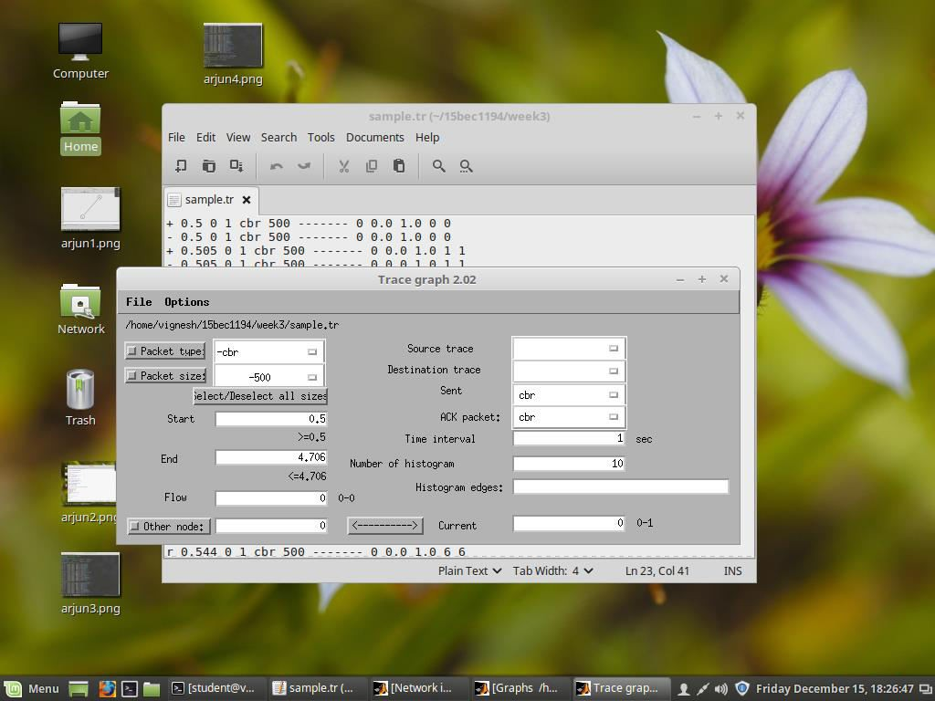

**Selecting the source node by setting the current as 0.**

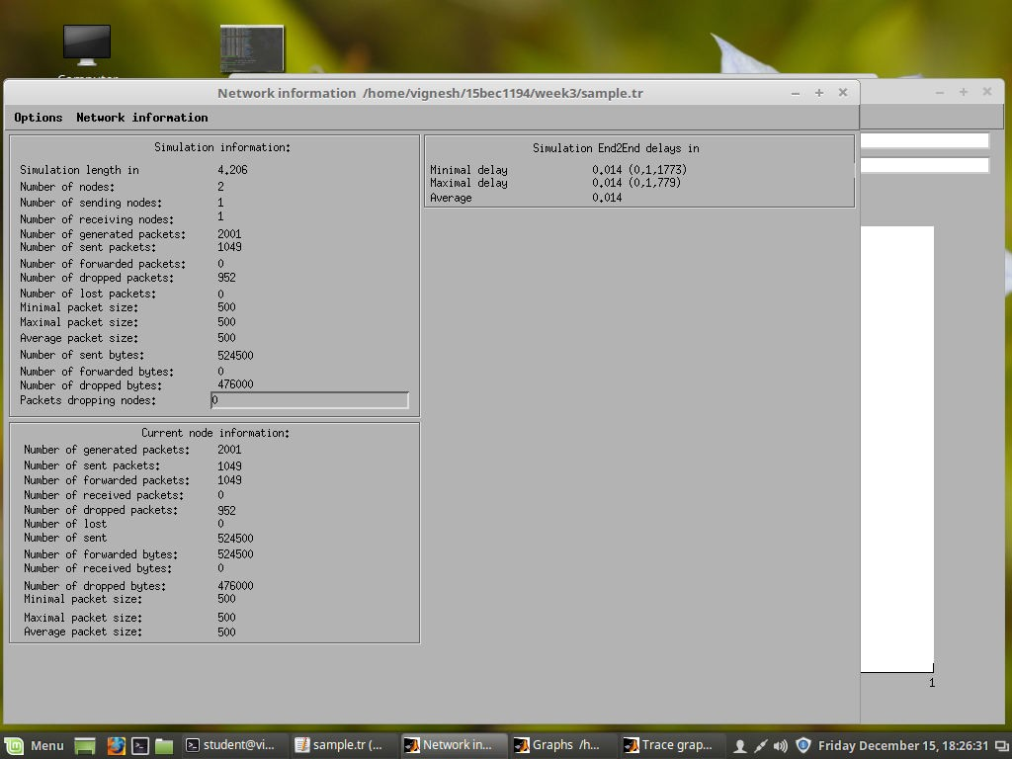

**Information of the source node using trace graph**

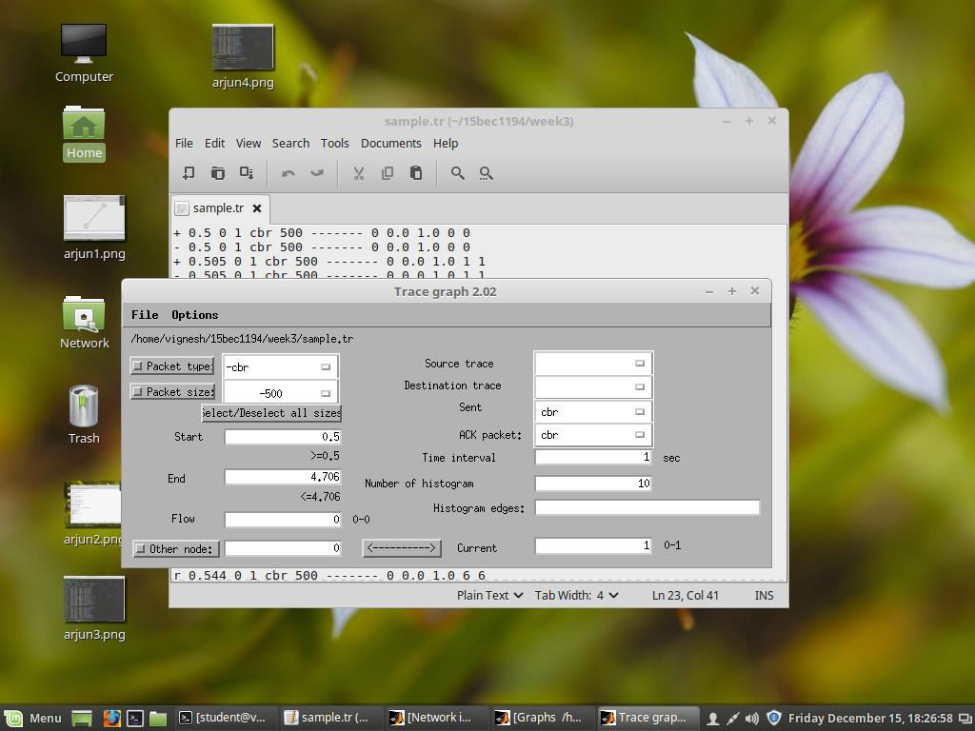

**Selecting the destination node by making the current value equal to 1**

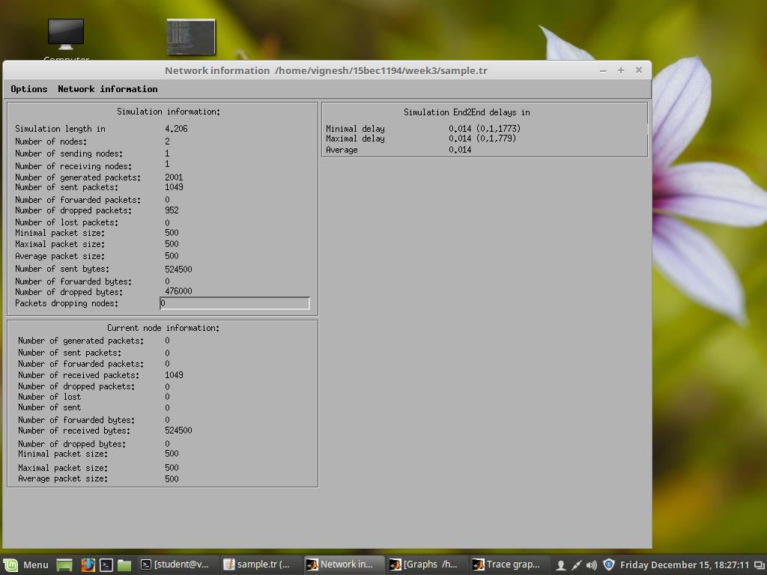

**Information at the destination node using trace graph**

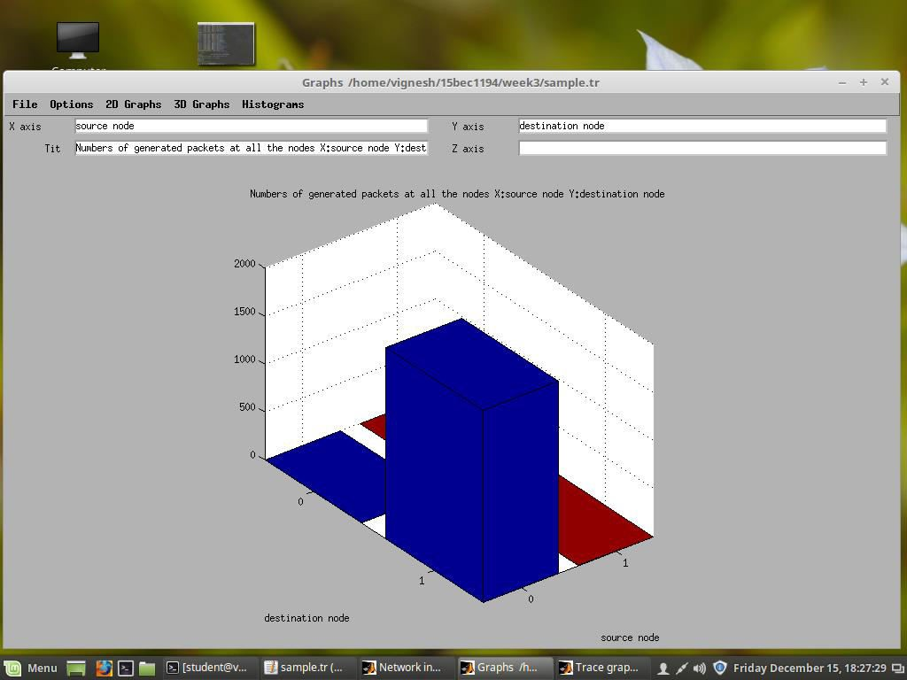

* 1. **graph of number of packets generated at all nodes.**

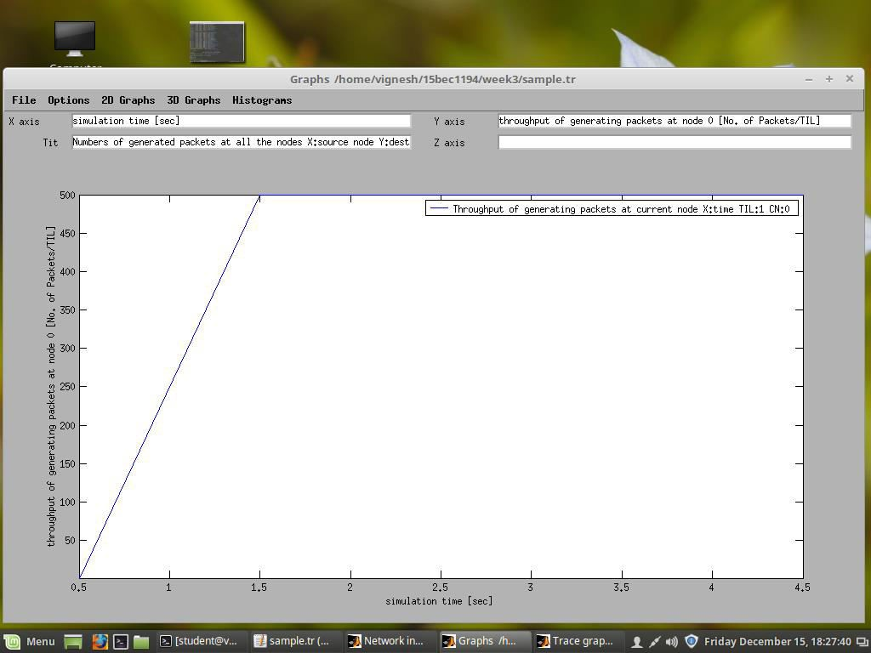

**Throughput graph of the source node.**

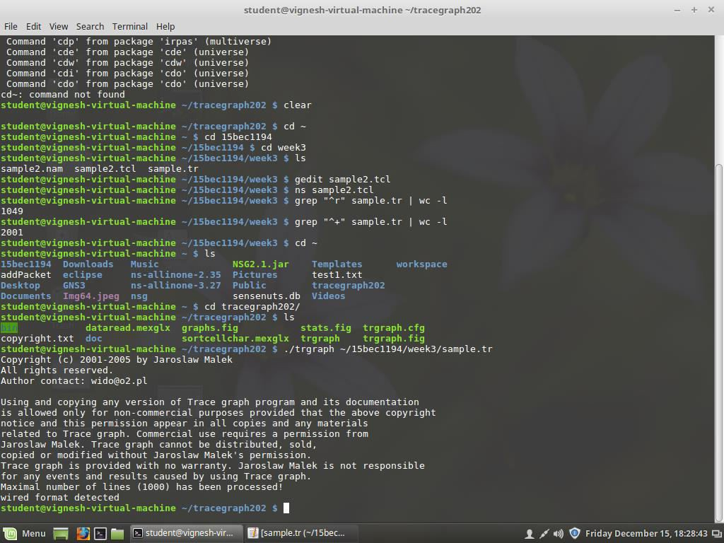

**Inference:** If the data generation rate is greater than the link rate, not all the packets get serviced, thus we observe that some of the packets getting dropped.

**Result:** The end to end delay is 0.014 seconds.

PDR in case 1 is 100

PDR in case 2 is 52.52

Thus study of linux commands and TCL, and simulation and analysis of point to point wired network using NS2 were successfully executed.

#### Experiment 3

**COMPUTER COMMUNICATION LAB ECE4004**

**Name: Debasya Sahoo**

**Registration number: 15BEC1111**

**Aim:**

* + - Simulation and analysis of queuing mechanism in star topology using NS2.

#### Software: NS2 and Trace Graph Description:

* + - First create a new directory.
    - Go to that directory and create a file sample3.tcl
    - Open the file and write the tcl script.
    - Save and compile and run the tcl script
    - Use grep commands for pdr calculation.
    - Using trace graph for visual simulation.

#### Code:

**#Create an instance of simulator class**

set ns [new Simulator]

#### #Create a Trace file

set tf [open star.tr w]

$ns trace-all $tf

#### #Create a NAM file

set nf [open star.nam w]

$ns namtrace-all $nf

#### #Create nodes and duplex links

set num 4

for {set i 0} {$i< $num} {incri} { set n($i) [$ns node]

}

#### # Create duplex link between source and target of 1Mb BW, 10ms propagation delay and DropTail queueing mechanism

$ns duplex-link $n(0) $n(2) 1Mb 10ms DropTail

$ns duplex-link $n(1) $n(2) 1Mb 10ms DropTail

$ns duplex-link $n(2) $n(3) 1Mb 10ms DropTail

#### # Create Transport Agents

**#Create UDP object**

set udp0 [new Agent/UDP]

#### #Attach the UDP object to $n0

$ns attach-agent $n(0) $udp0

#### # Generate Application Traffic

**# Constant Bit Rate Application (CBR)**

set cbr0 [new Application/Traffic/CBR]

$cbr0 set packetSize_ 500

$cbr0 set interval_ 0.005

$cbr0 attach-agent $udp0

#### #Create a NULL object and attach it to node 3

set null0 [new Agent/Null]

$ns attach-agent $n(3) $null0

#### #Virtually connect these 2 agents

$ns connect $udp0 $null0

#### # Doing the same for node 1

set udp1 [new Agent/UDP]

$ns attach-agent $n(1) $udp1

set cbr1 [new Application/Traffic/CBR]

$cbr1 set packetSize_ 500

$cbr1 set interval_ 0.005

$cbr1 attach-agent $udp1

$ns connect $udp1 $null0

**#Finish Procedure** proc finish {} { global ns nftf

#### # flush-trace: Dumps all content to trace and nam file

$ns flush-trace close $nf close $tf

exec namstar.nam& exit 0

}

#### #Specifying the start and the stop time

$ns at 0.5 "$cbr0 start"

$ns at 1.0 "$cbr1 start"

$ns at 4.5 "$cbr0 stop"

$ns at 4.5 "$cbr1 stop"

$ns at 5.0 "finish"

$ns run

#### Output:

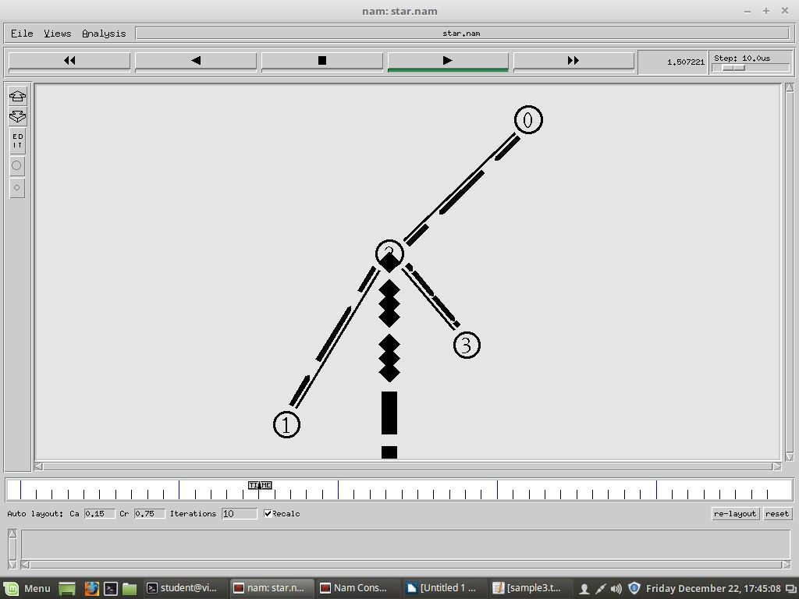

**Calculating pdr using grep commands: Trace graph simulation output for all nodes:**

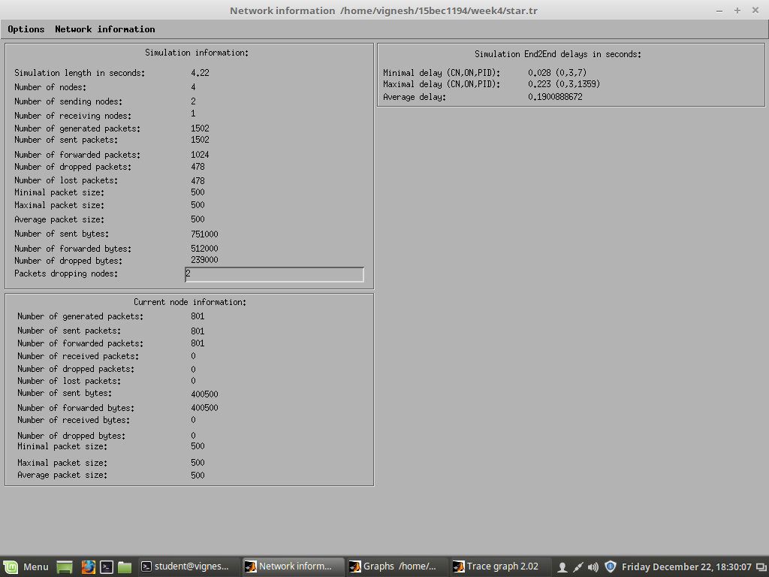

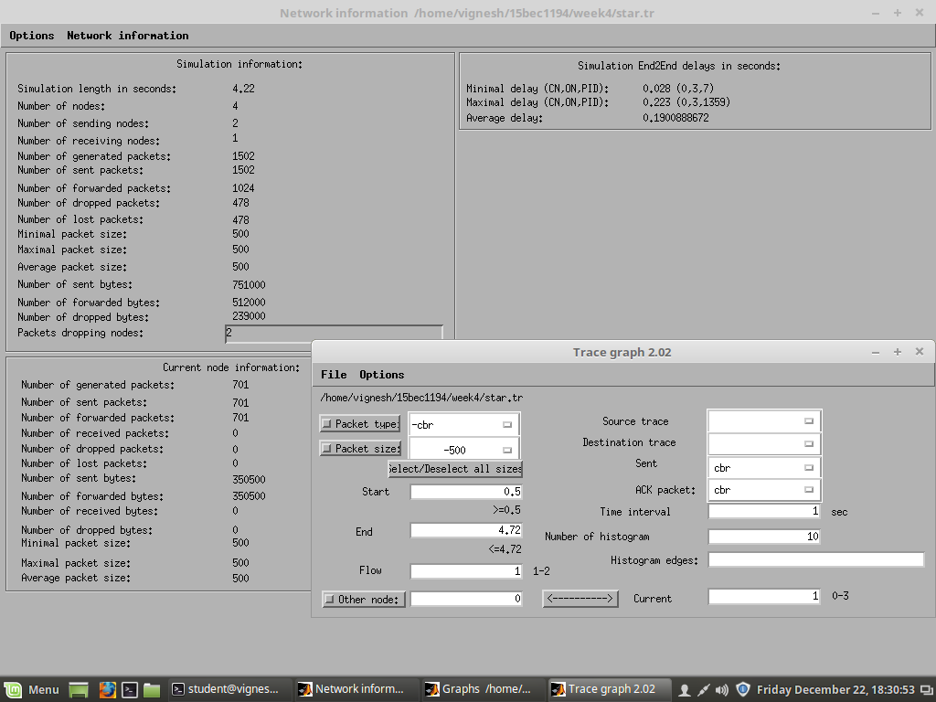

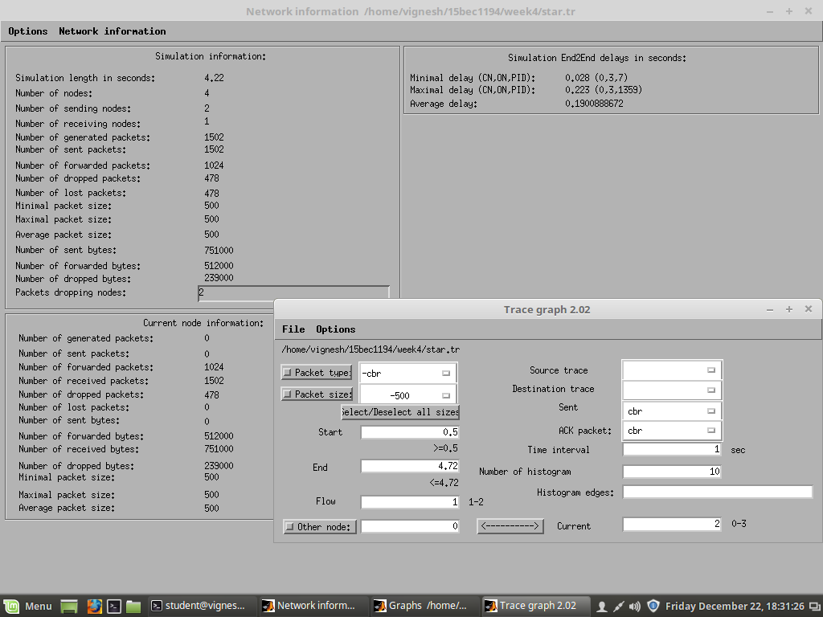

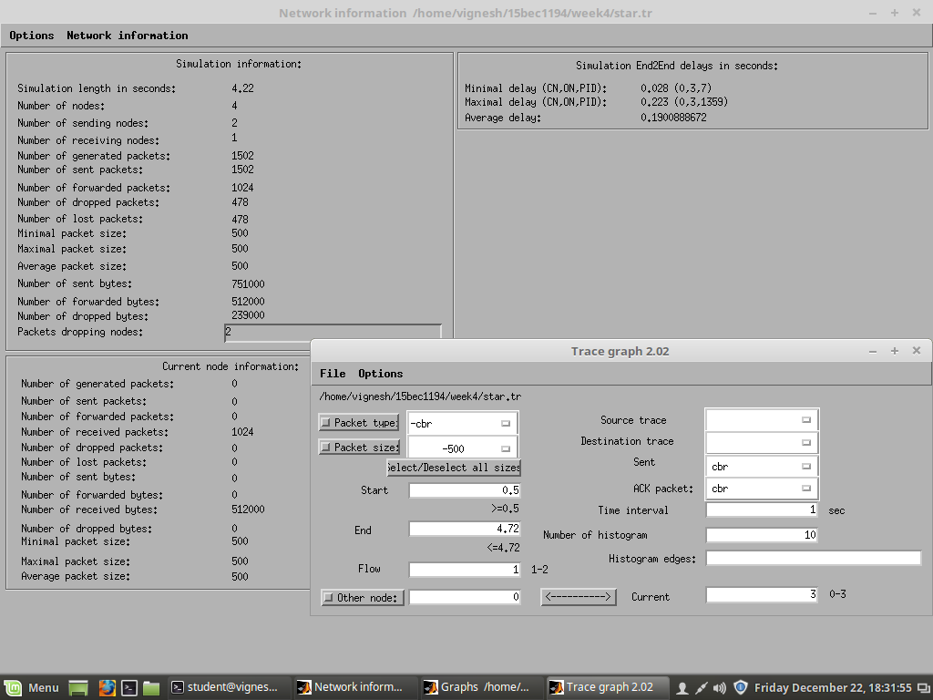

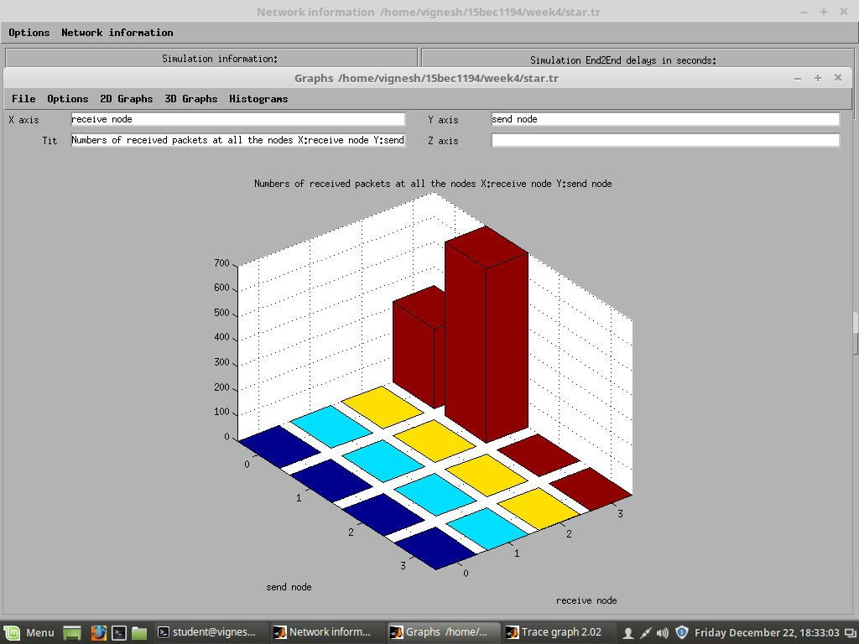

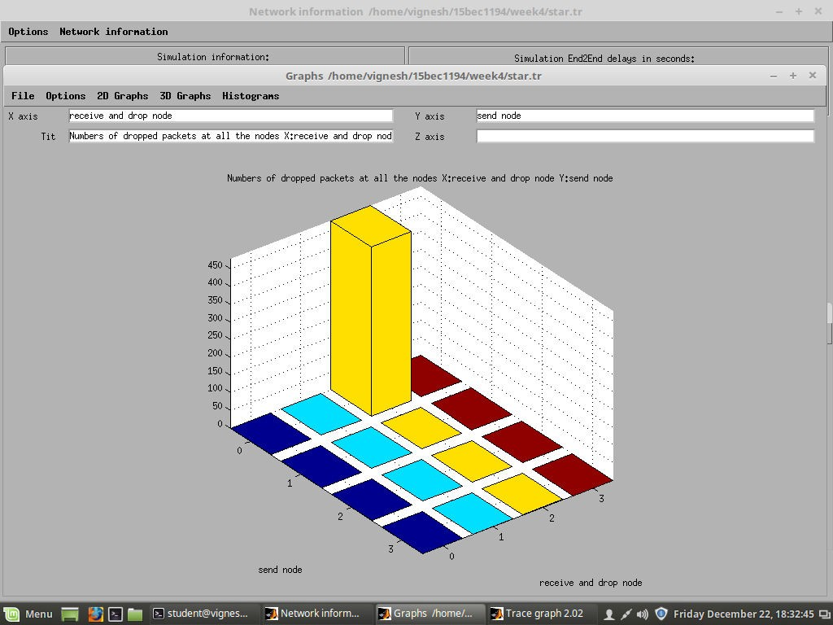

**Biased dropping of packets of only node 0**

**Code 2 using SFQ mechanism.**

**#Create an instance of simulator class**

set ns [new Simulator]

set tf [open star.tr w]

$ns trace-all $tf

set nf [open star.nam w]

$ns namtrace-all $nf set num 4

$ns color 1 Blue

$ns color 2 Red

for {set i 0} {$i< $num} {incri} { set n($i) [$ns node]

}

$ns duplex-link $n(0) $n(2) 1Mb 10ms DropTail

$ns duplex-link $n(1) $n(2) 1Mb 10ms DropTail

#### # SFQ - Stochastic Fair Queing

$ns duplex-link $n(2) $n(3) 1Mb 10ms SFQ

#### # Duplex link orientation

$ns duplex-link-op $n(0) $n(2) orient right-down

$ns duplex-link-op $n(1) $n(2) orient right-up

$ns duplex-link-op $n(2) $n(3) orient right

#### # queue position see how the buffer gets filled

$ns duplex-link-op $n(2) $n(3) queuePos 0.5

set udp0 [new Agent/UDP]

$udp0 set class_ 1

$ns attach-agent $n(0) $udp0

set cbr0 [new Application/Traffic/CBR]

$cbr0 set packetSize_ 500

$cbr0 set interval_ 0.005

$cbr0 attach-agent $udp0

set null0 [new Agent/Null]

$ns attach-agent $n(3) $null0

$ns connect $udp0 $null0

set udp1 [new Agent/UDP]

$udp1 set class_ 2

$ns attach-agent $n(1) $udp1

set cbr1 [new Application/Traffic/CBR]

$cbr1 set packetSize_ 500

$cbr1 set interval_ 0.005

$cbr1 attach-agent $udp1

$ns connect $udp1 $null0 proc finish {} {

global ns nftf

$ns flush-trace close $nf close $tf

exec namstar.nam& exit 0

}

$ns at 0.5 "$cbr0 start"

$ns at 1.0 "$cbr1 start"

$ns at 4.5 "$cbr0 stop"

$ns at 4.5 "$cbr1 stop"

$ns at 5.0 "finish"

$ns run

#### Output:

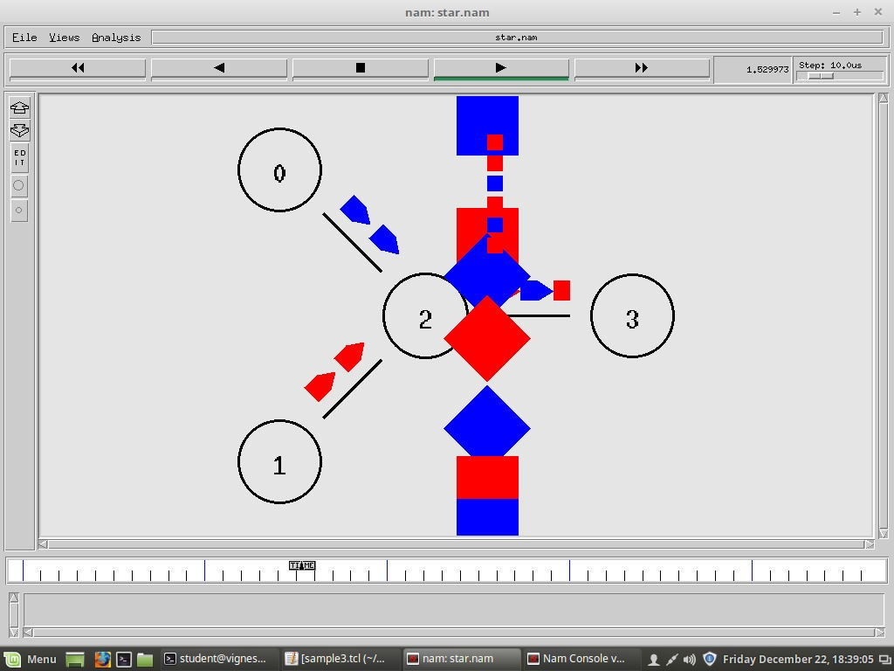

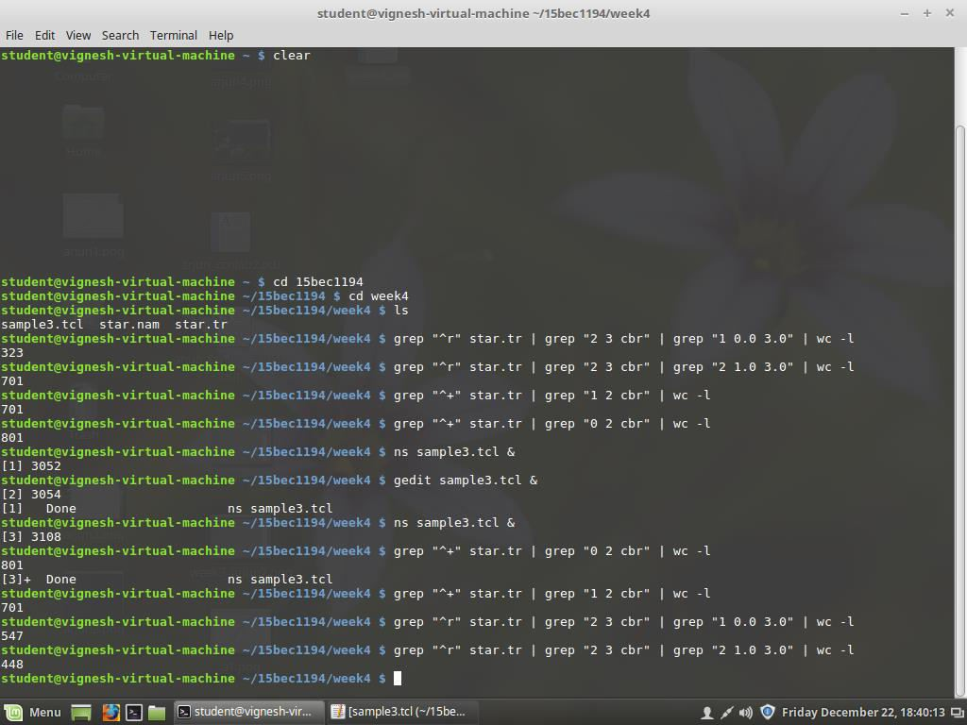

**Calculating pdr using grep commands**

**Trace graph simulation outputs for different nodes.**

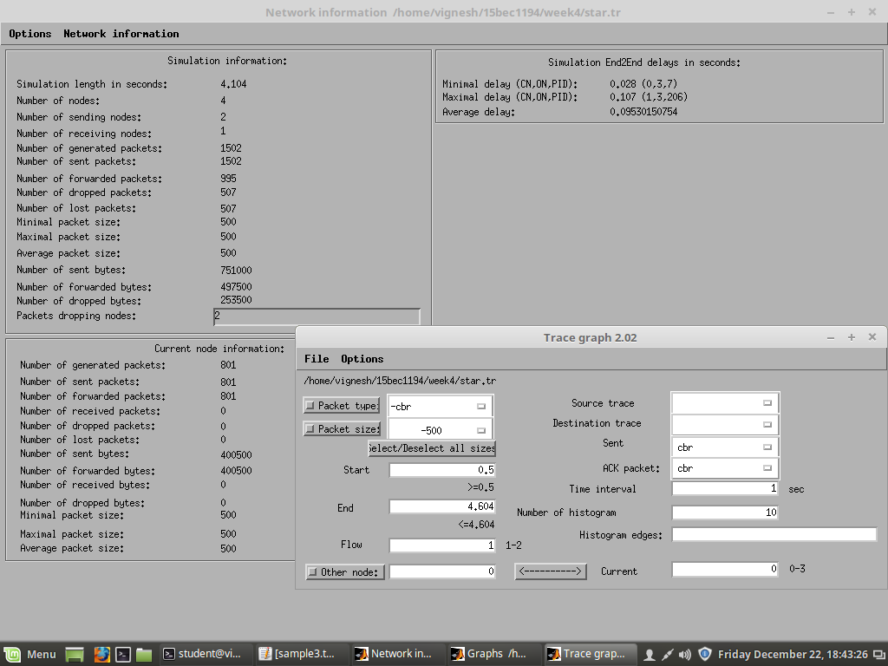

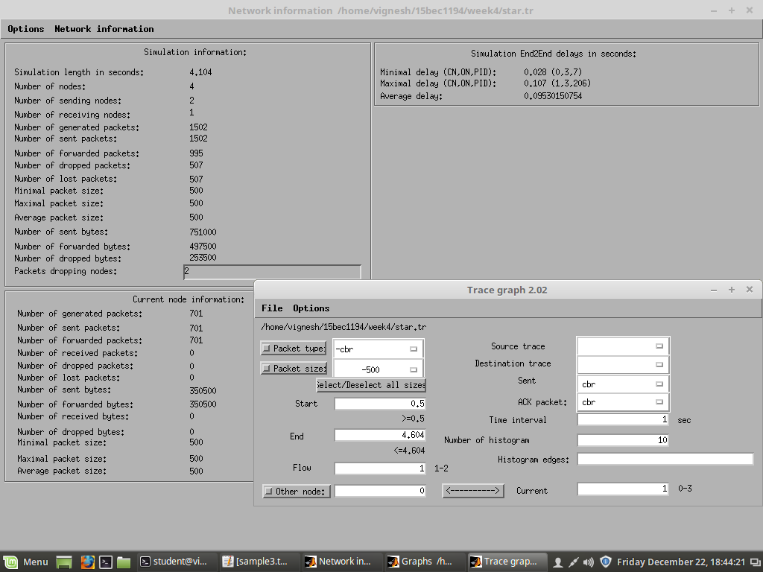

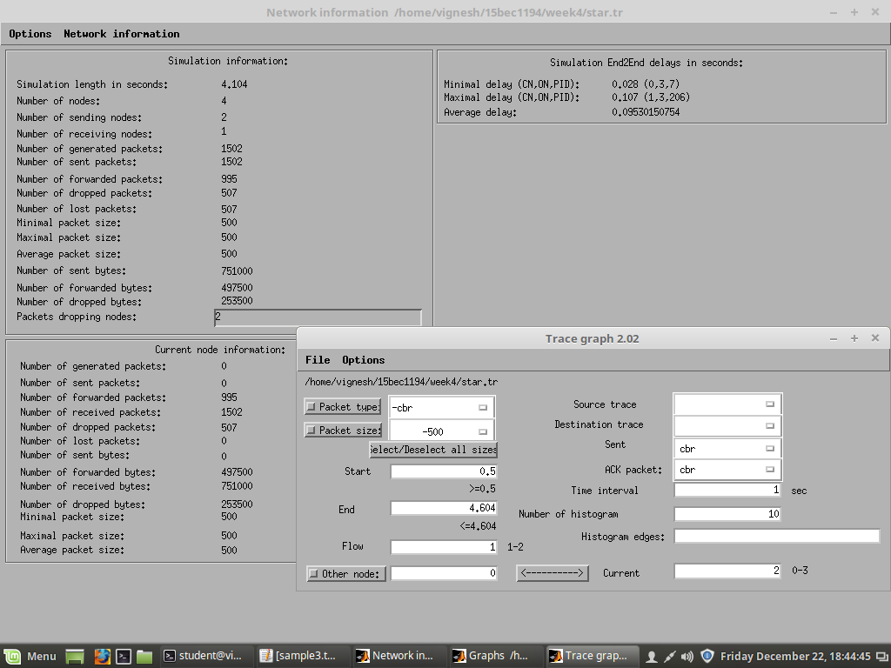

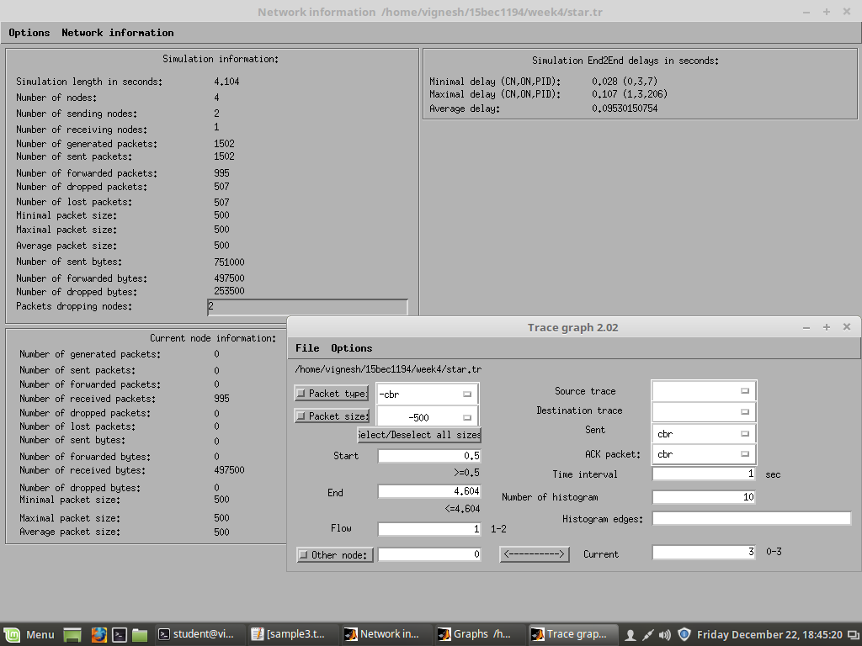

**Packets of both get dropped.**

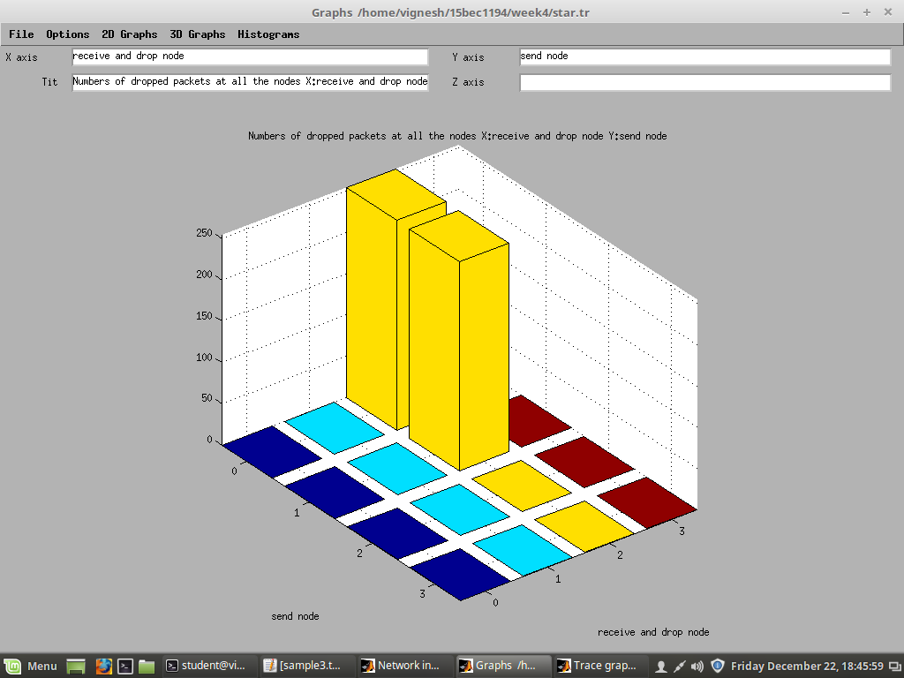

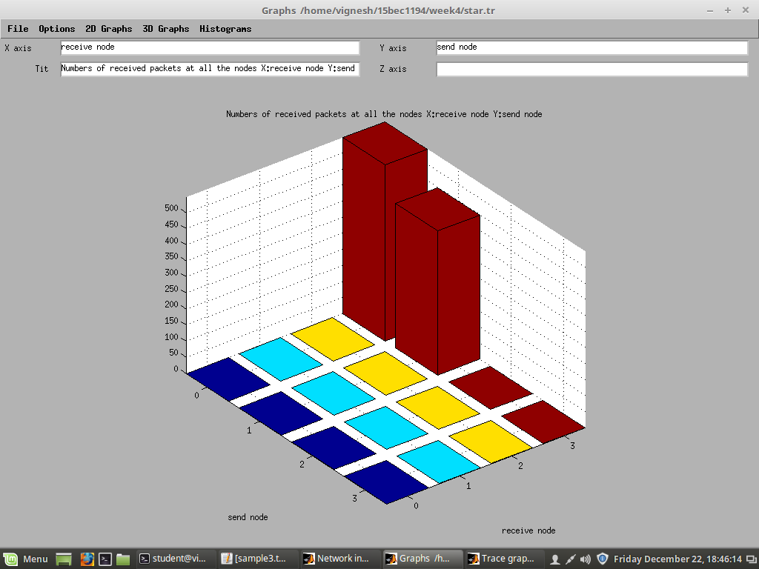

**We can observe that both nodes get equally treated.**

**Inferences:**

* + - **From the above mechanism we inferred that the DropTail queuing mechanism is unfair, since there is biasing involved, the node 1 gets more service compared to node 0.**
    - **On the other hand, the Stochastic Fair Queuing (SFQ) is much better since it services both the nodes fairly and there’s no biasing involved.**
    - **We can also see that the PDR for SFQ is fairer than PDR for DropTail. Results:**
    - Packet Delivery Ratio (PDR)

**Using DropTail mechanism** PDR (n0-n3) = 323/801 = 40.37% PDR (n1-n3) = 701/701 = 100%

#### Using SFQ mechanism

PDR (n0-n3) = 547/801 = 68.28% PDR (n1-n3) = 448/701 = 63.90%

* + - **Average end to end delay** of 0.0953s (95.3 ms) is observed.

***Name:*** *Debasya Sahoo*

#### Experiment 4

#### COMPUTER COMMUNICATION LAB

**ECE4008**

***Registration number:*** *15BEC1111*

**Aim:** Simulation of ring topology and analysis of static/dynamic routing in case of link/node failures.

**Software:** NS2 and Trace Graph

#### Description:

* + - Open the terminal and go to your own directory.
    - Create a new directory week4 and open a tcl file.
    - Write the tcl script, save and compile.
    - Run the tcl script.
    - Make use of grep commands for calculation of pdr.
    - Using trace graph calculate the average end to end delay.

#### Code:

**#Create an instance of simulator class**

set ns [new Simulator]

#### # Enable Dyanamic Routing in Ns2

**#DV - Distance Vector Routing Protocol**

$ns rtproto DV

#### #Create a Trace file

set tf [open ring.tr w]

$ns trace-all $tf

#### #Create a nam file

set nf [open ring.nam w]

$ns namtrace-all $nf

#### # Creating nodes

set num 7

for {set i 0} {$i< $num} {incri} { set n($i) [$ns node]

}

#### #Creating duplex-link

for {set i 0} {$i< $num} {incri} {

$ns duplex-link $n($i) $n([expr ($i+1)%$num]) 1Mb 10ms DropTail

}

#### #Create Transport Agent

**#Create UDP object**

set udp0 [new Agent/UDP]

#### #Attach the UDP object to $n0

$ns attach-agent $n(0) $udp0

#### # Generate Application Traffic

**# Constant Bit Rate Application (CBR)**

set cbr0 [new Application/Traffic/CBR]

$cbr0 set packetSize_ 500

$cbr0 set interval_ 0.005

$cbr0 attach-agent $udp0

#### #Create a NULL object and attach it to node 3

set null0 [new Agent/Null]

$ns attach-agent $n(3) $null0

#### #Virtually connect these 2 agents

$ns connect $udp0 $null0

#### #Finish Procedure

proc finish {} { global ns nftf

#### # flush-trace: Dumps all content to trace and nam file

$ns flush-trace close $tf

close $nf

exec namring.nam& exit 0

}

#### # Schedule Traffic

$ns at 0.5 "$cbr0 start"

#### # Use rtmodel-at to set a link/node down/up

$ns rtmodel-at 1.0 down $n(1) $n(2)

$ns rtmodel-at 2.0 up $n(1) $n(2)

$ns at 4.5 "$cbr0 stop"

$ns at 5.0 "finish"

#### # Assign different weights to edges

$ns cost $n(2) $n(3) 5

#### # Run the Script

$ns run

#### Output:

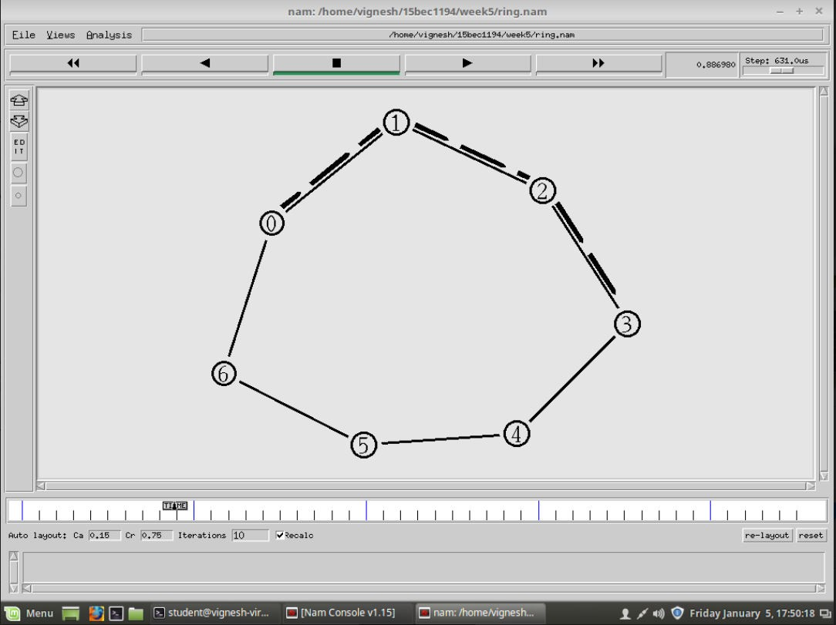

The shortest path is taken by default.

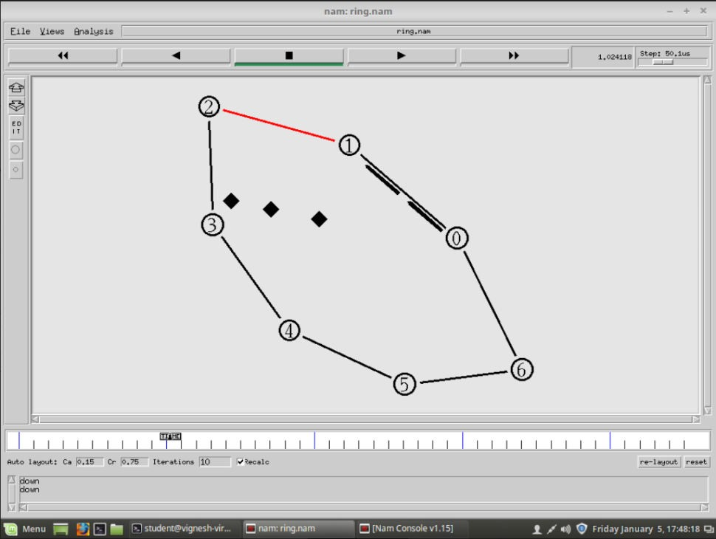

During 1s to 2s the link between node 1 and 2 is down thus no packets received at node 3

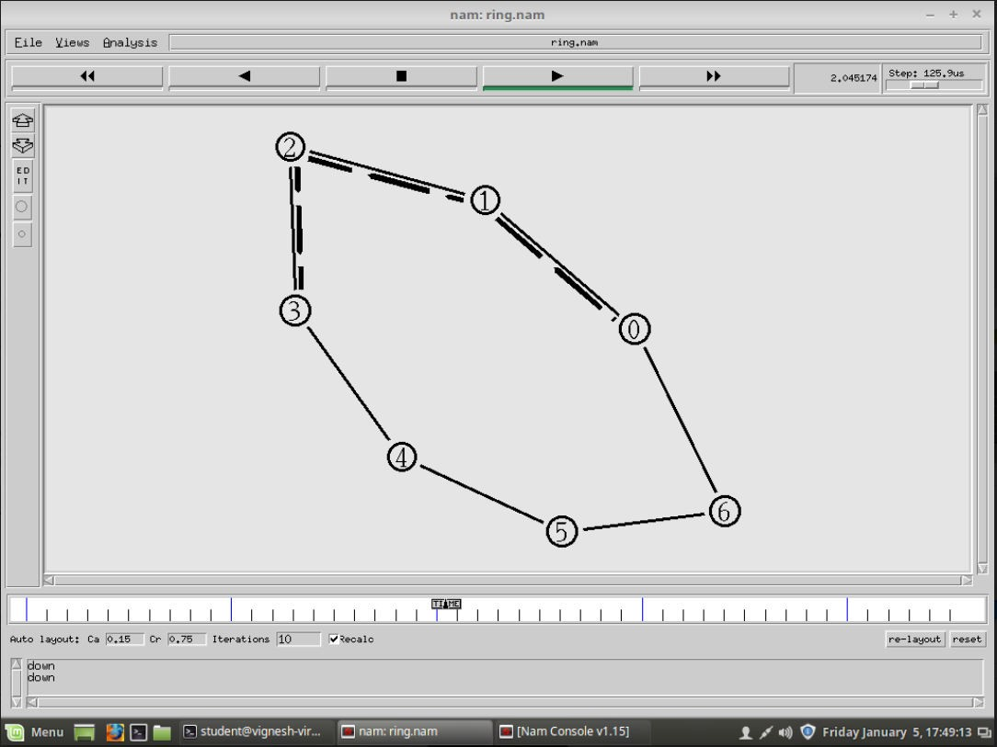

After 2s the link is up again thus packets get transferred

Calculation of pdr using grep commands

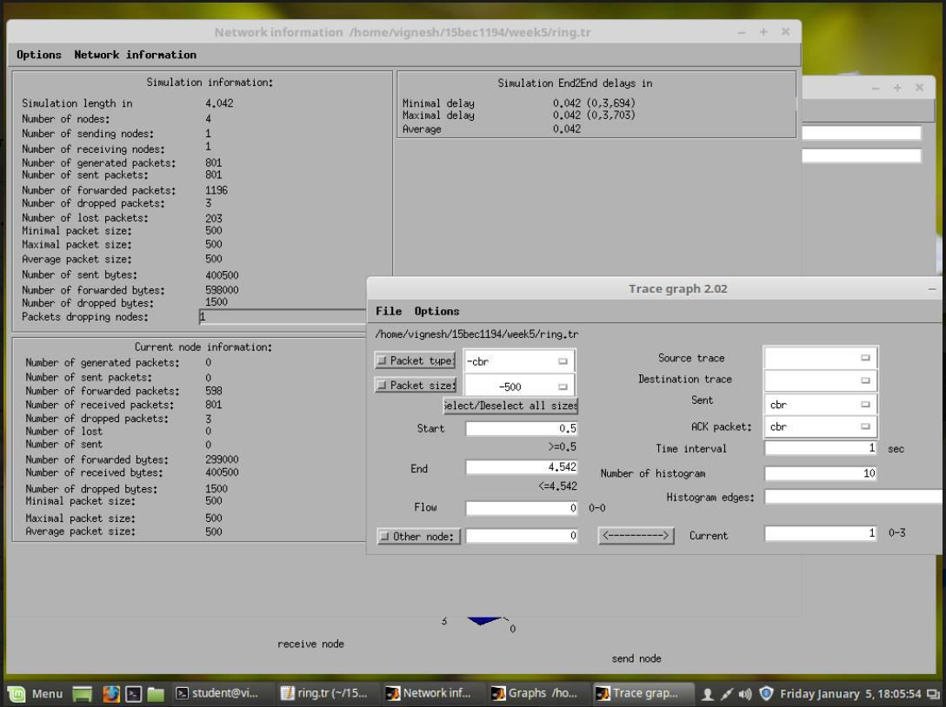

Using trace graph to determine average end to end delay.

Making use of dynamic routing protocol so that the packets are sent via different path when link between node 1 and node 2 fails.

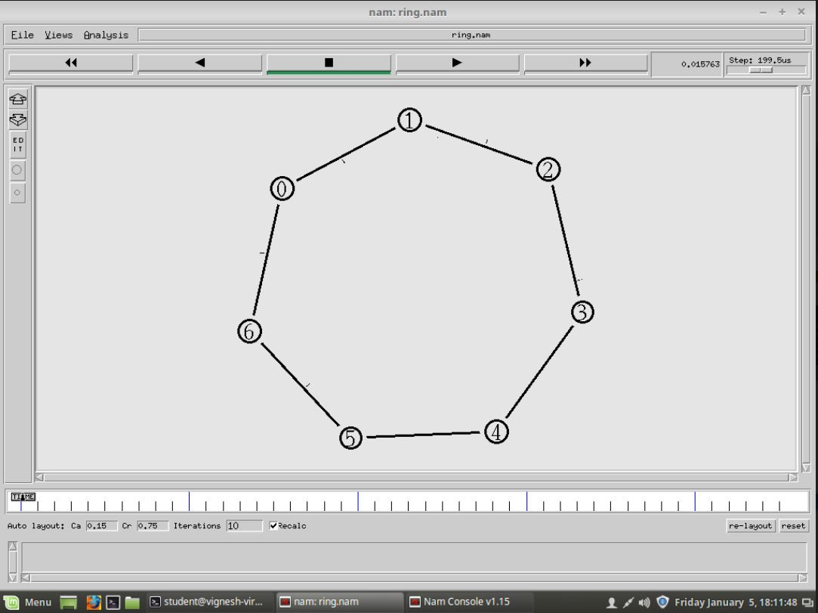

When the link fails the longer path is chosen for delivering the packets.

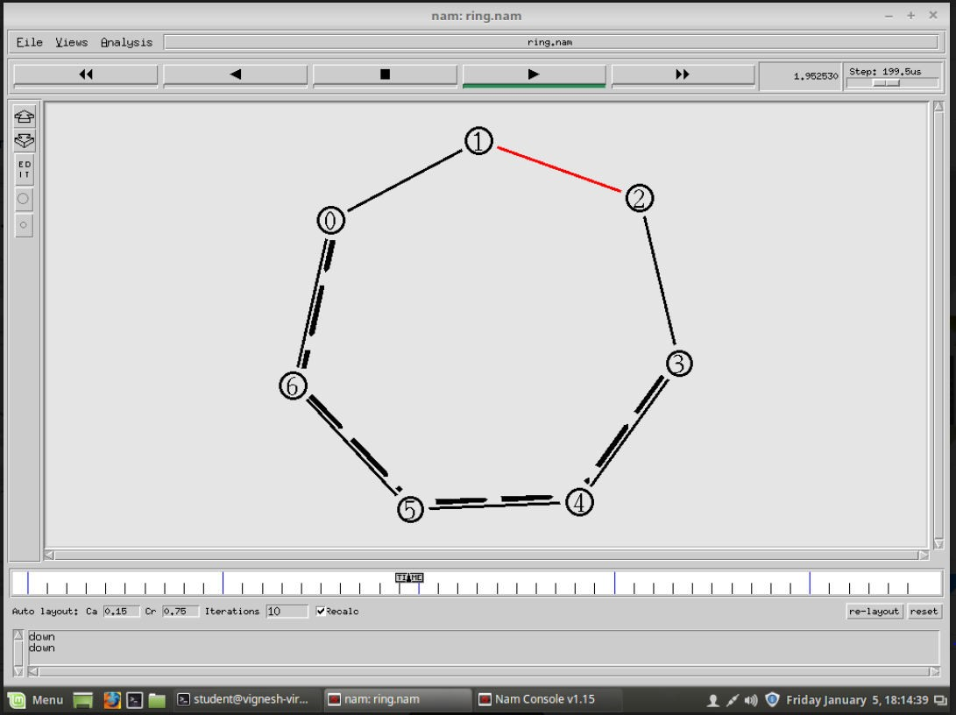

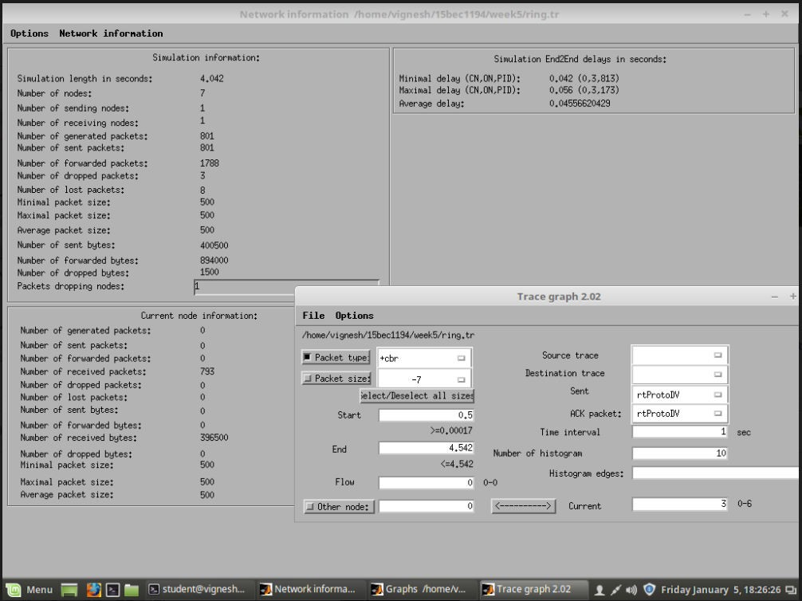

Using trace graph to determine average end to end delay.

In case of node failure

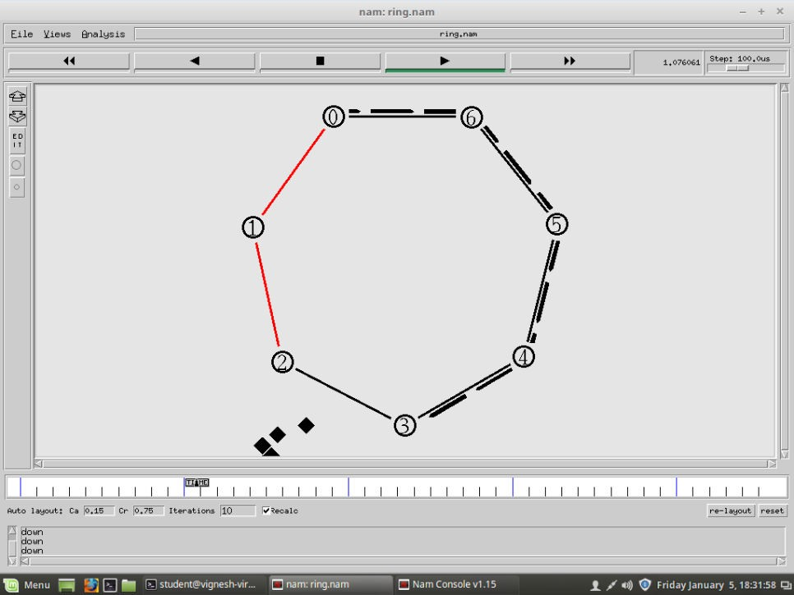

In case the weights of the links are changed

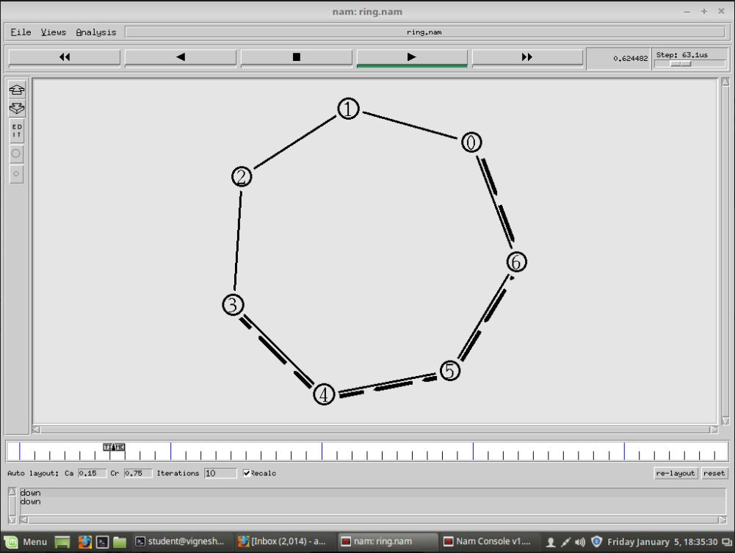

The weights from 0-1-2-3 are more as compared to 0-6-5-4-3.

Thus, the shortest path is now the longest path earlier. Even when the link fails this path is not affected, thus the pdr remains 100%

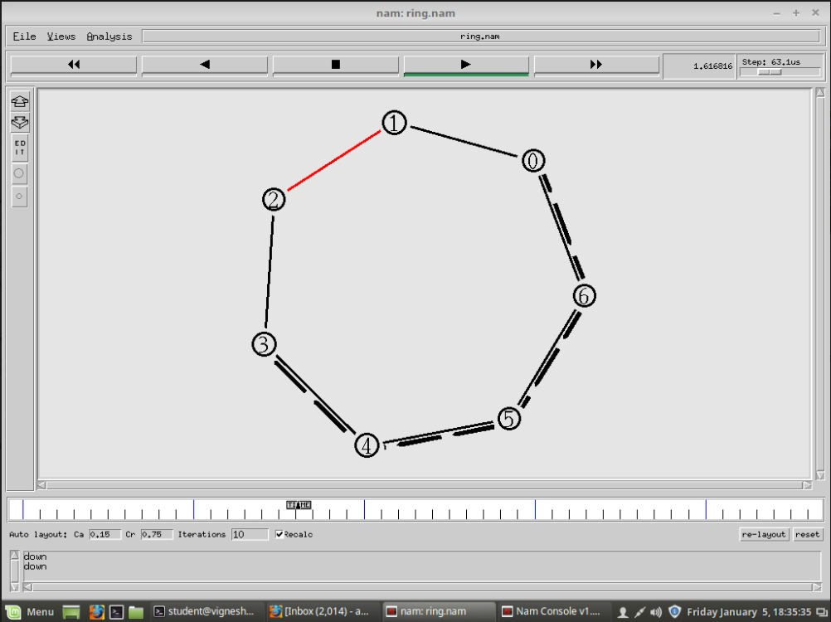

#### Inferences:

* + - When we create a ring topology and set the start and destination node, the packets are sent via the shortest path by default.
    - In case the link is down the packets start getting lost unless we start using dynamic routing protocol, after which in case the link fails, the packets are transferred via another path.
    - This protocol sends few bits after the start time which analyses all the path from starting node to destination node. These values are stored routing table which is referred in case of link/node failure.
    - In case we assign weights to the links the shortest path get changed accordingly.
    - We observe that the average end to end delay increases after we use the dynamic routing protocol this is because when the link fails the protocol switches to another route, thus switching and the time to travel via another route increase the delay.
    - Even though the delay is increased we are able to achieve higher PDR after the use to dynamic routing protocol, which is much intended.

#### Results:

* + - PDR before dynamic routing protocol:

#### PDR = 598/801 * 100 = 74.65%

**Average end to end delay = 0.042 s**

* + - PDR after dynamic routing protocol

#### PDR = (591+202)/(599+202) * 100 = 99%

**Average end to end delay = 0.0455 s**

**Experiment 5**

**COMPUTER COMMUNICATION LAB**

**Study and Analysis of Network Performance using NETSIM**

***Name: Debasya Sahoo Registration number: 15BEC1111***

**Aim:** To study the performance of a Computer Network, by changing various factors of the network, using NetSim.

Different Factors are

* Increasing the traffic (Increasing the Packet Generation Rate for fixed number of Applications)
* Increasing the number of users (Increasing the number of nodes / Applications with fixed packet generation rate)
* Increasing the bit error rate across links

#### Network Simulation Specifications:

1. No of Nodes = 6 ; No of Destination Node = 1 (Node 6) ; No of Applications (CBR) = 3 (3 nodes Application Traffic) ; Vary the Packet Inter-arrival Time : 20ms, 15ms, 10ms, 5ms

Link Speed = Switch to Destination = 5Mbps (Duplex);

Only UDP sources ; Dynamic ARP enabled ; Simulation time : 10seconds

* + **Inference (Plots):** Calculate the Average Application Throughput & Average Delay vs Packet Inter-arrival Time

20ms:

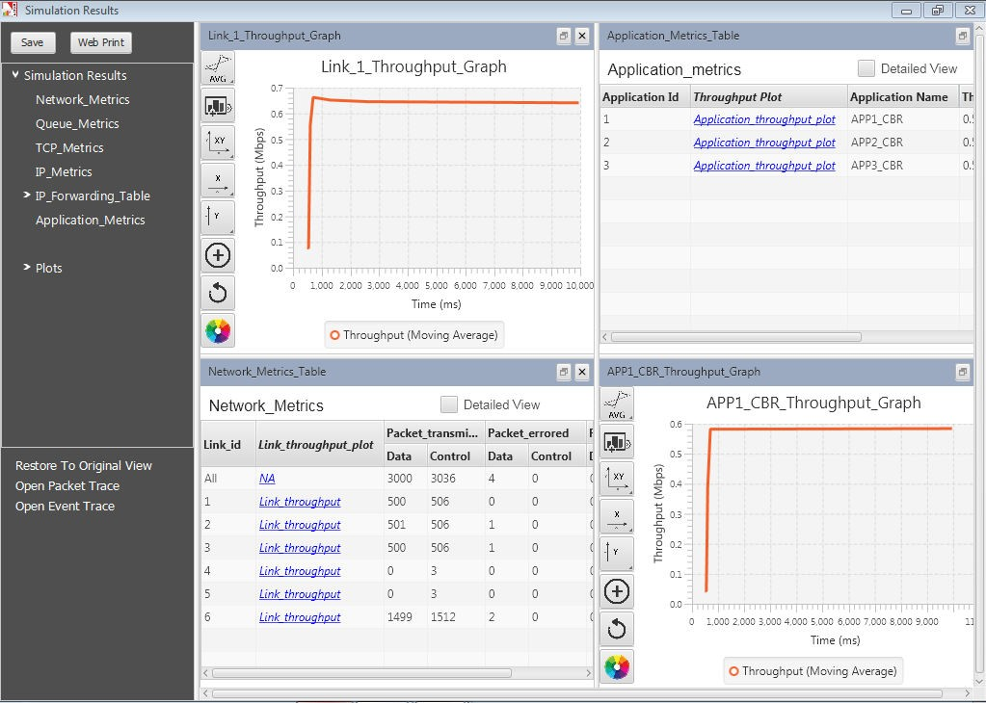

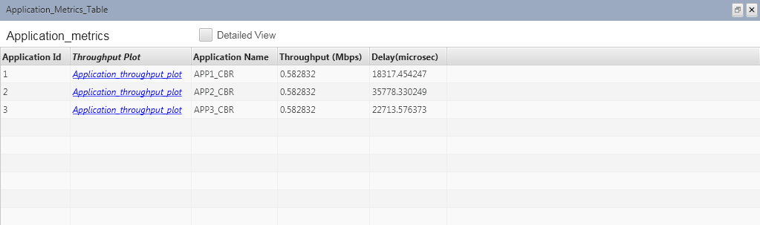

**Average application throughput: 0.58 Mbps Average delay: 25603 us**

15ms:

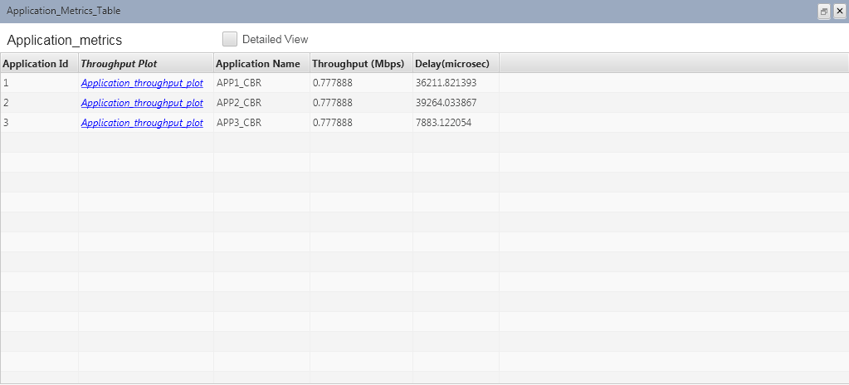

**Average application throughput: 0.78Mbps Average delay: 27786 us**

10ms:

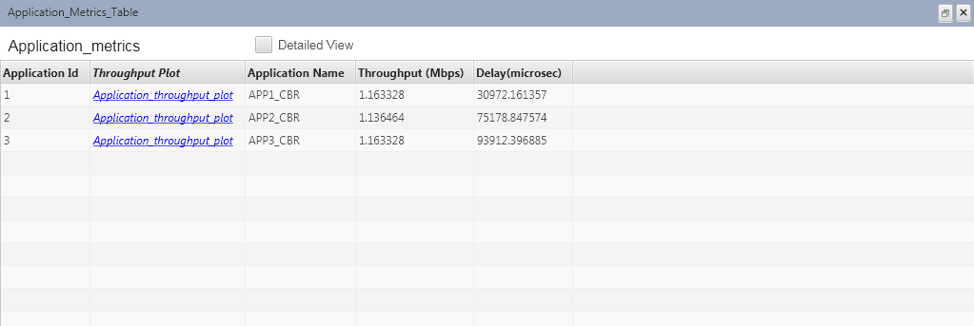

**Average application throughput: 1.15Mbps Average delay: 66687 us**

5ms:

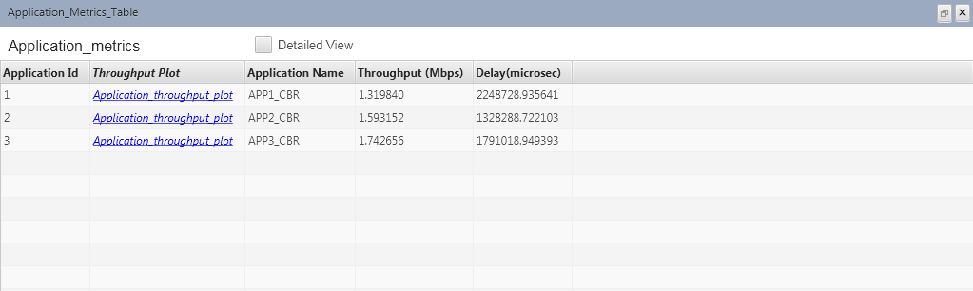

**Average application throughput: 1.55Mbps Average delay: 1789344 us**

**Thus, we have,**

|  |  |  |
| --- | --- | --- |
| **Packet Inter-arrival time (ms)** | **Average application throughput (Mbps)** | **Average delay (us)** |
| 20 | 0.58 | 25603 |
| 15 | 0.78 | 27786 |
| 10 | 1.15 | 66687 |
| 5 | 1.55 | 1789344 |

1. No of Nodes = 6 ; Packet Inter-arrival Time = 5ms ; Increase the number of Application Traffics (nodes in this case) = 1, 2, 3, 4, 5 ; No of Destination Node = 1 Link Speed = Switch to Destination = 5Mbps (Duplex)
   * **Inference (Plots):** Calculate the Average Application Throughput & Average Delay vs No of Application Traffic/Nodes

Number of nodes: 1

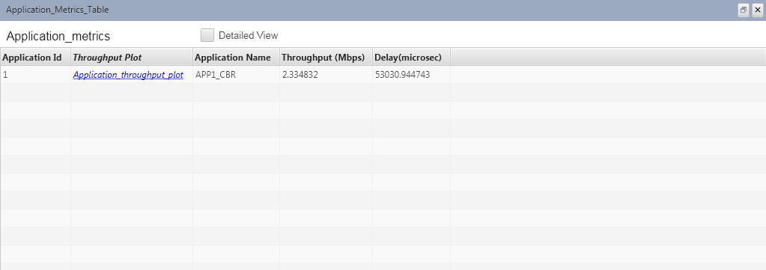

Number of nodes: 2

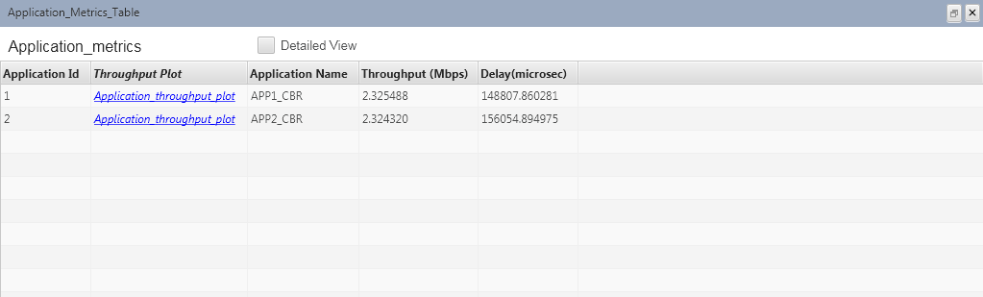

Number of nodes: 3

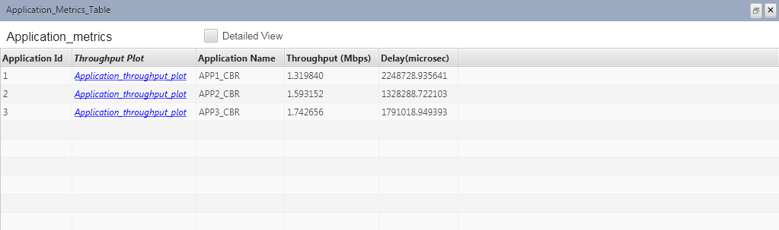

Number of nodes: 4

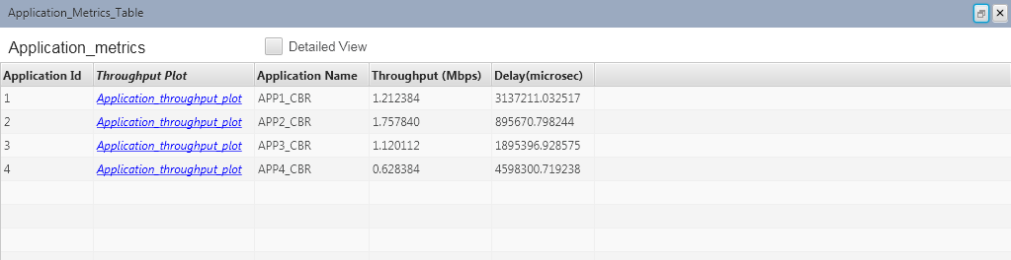

Number of nodes: 5

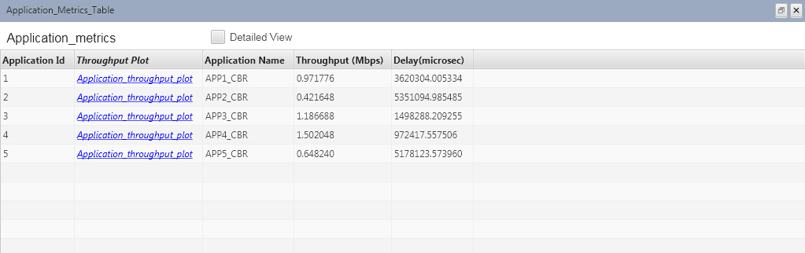

|  |  |  |
| --- | --- | --- |
| **Number of application traffic/node** | **Average application throughput (Mbps)** | **Average delay (us)** |
| 1 | 2.33 | 53030 |
| 2 | 2.32 | 152430 |
| 3 | 1.55 | 1789344 |
| 4 | 1.18 | 2631644 |
| 5 | 0.95 | 3324045 |

1. No of Nodes = 6 ; No of Destination Node = 1 ; No of Applications (CBR) = 3 (3 nodes Application Traffic) ; Packet Inter-arrival Time : 10ms ; Vary the BER : 10^-8, 10^-6, 10^-5 across active links

Link Speed = Switch to Destination = 5Mbps (Duplex)

* + **Inference (Plots):** Calculate the Average Application Throughput & Average Delay vs BER

10^-8:

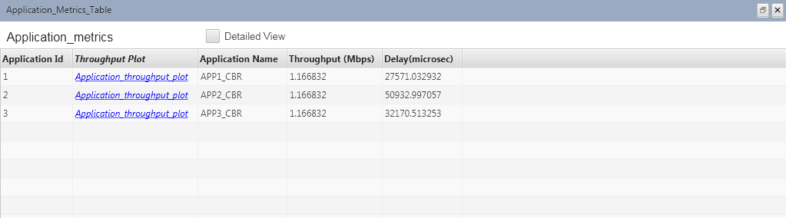

10^-6:

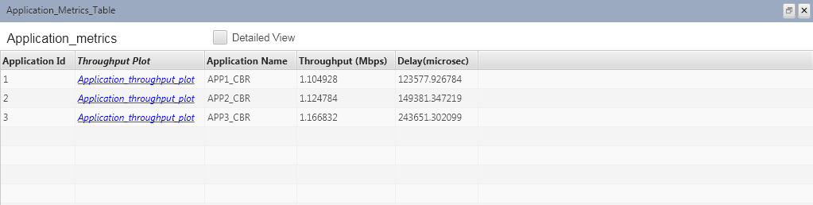

10^-5:

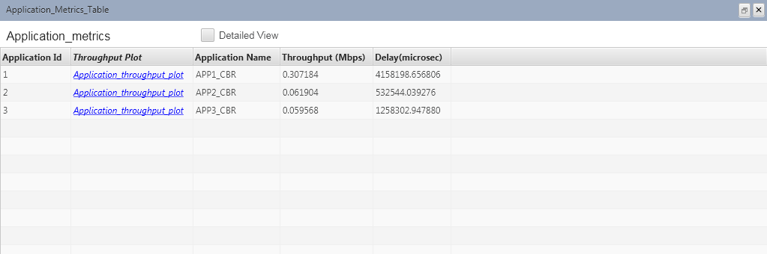

|  |  |  |
| --- | --- | --- |
| **BER** | **Average application throughput (Mbps)** | **Average delay (us)** |
| 10-8 | 1.17 | 36891 |
| 10-6 | 1.13 | 172203 |
| 10-5 | 0.14 | 1983014 |

1. No of Nodes = 6; No of Destination Nodes = 5 ; No of Applications (CBR) = 5 ; Source-Destination Pairs : 1-2, 2-3, 3-4, 4-5, 5-6 ; Vary the Packet Inter-arrival Time : 5ms, 10ms, 15ms and 20ms

Link Speed = Switch to Destination = 5Mbps (Duplex)

* + **Inference (Plots):** Calculate the Average Application Throughput & Average Delay vs Packet Inter-arrival Time
  + Compare this scenario with Scenario 1 and infer if any difference in metrics results.

20ms:

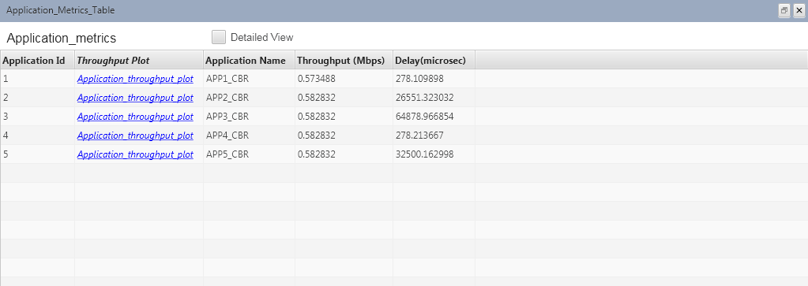

15ms:

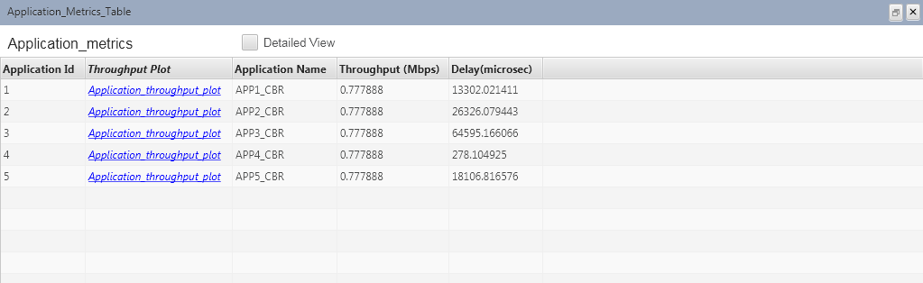

10ms:

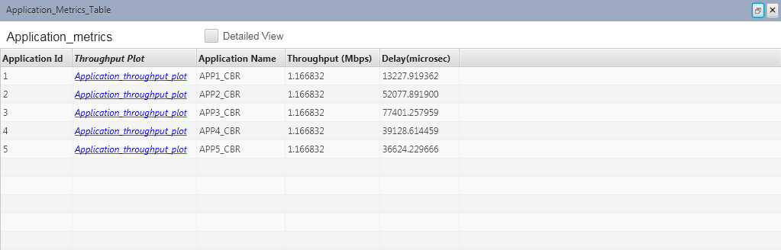

5ms:

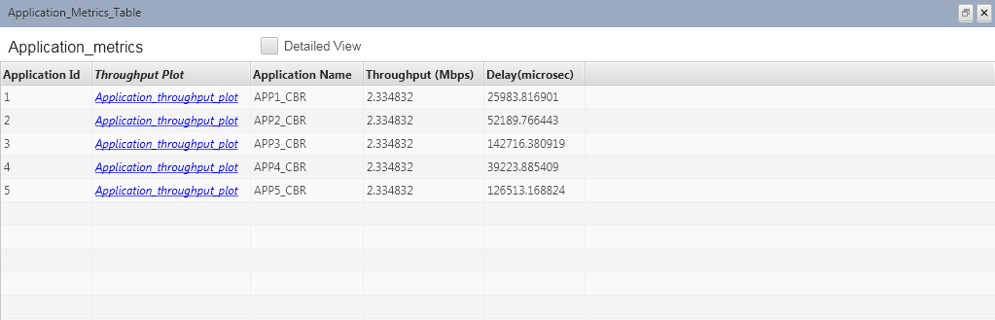

|  |  |  |
| --- | --- | --- |
| **Packet Inter-arrival time (ms)** | **Average application throughput (Mbps)** | **Average delay (us)** |
| 20 | 0.58 | 24897 |
| 15 | 0.78 | 24521 |
| 10 | 1.17 | 43691 |
| 5 | 2.33 | 77324 |

#### Observations, Graphs and Inferences:



Avg Application Throughput vs Packet Inter-arrival time

1.8

1.6

1.4

1.2

1

0.8

0.6

0.4

0.2

0

0

5

10

15

20

25

|  |  |  |
| --- | --- | --- |
| **Packet Inter-arrival time (ms)** | **Average application throughput (Mbps)** | **Average delay (us)** |
| 20 | 0.58 | 25603 |
| 15 | 0.78 | 27786 |
| 10 | 1.15 | 66687 |
| 5 | 1.55 | 1789344 |

|  |  |  |  |  |
| --- | --- | --- | --- | --- |
|  |  |  |  |  |
|  |  |  |  |  |
|  |  |  |  |  |
|  |  |  |  |  |
|  |  |  |  |  |
|  |  |  |  |  |
|  |  |  |  |  |
|  |  |  |  |  |
|  |  |  |  |  |

|  |  |  |  |  |
| --- | --- | --- | --- | --- |
|  |  |  |  |  |
|  |  |  |  |  |
|  |  |  |  |  |
|  |  |  |  |  |
|  |  |  |  |  |
|  |  |  |  |  |
|  |  |  |  |  |
|  |  |  |  |  |
|  |  |  |  |  |
|  |  |  |  |  |

**Inferences:**



Y-Values

2000000

1800000

1600000

1400000

1200000

1000000

800000

600000

400000

200000

0

0

5

10

15

20

25

* + - As the packet inter-arrival time increases the average application throughput decreases.
    - As the packet inter-arrival time increases the average delay decreases.

|  |  |  |
| --- | --- | --- |
| **Number of application traffic/node** | **Average application throughput (Mbps)** | **Average delay (us)** |
| 1 | 2.33 | 53030 |
| 2 | 2.32 | 152430 |
| 3 | 1.55 | 1789344 |
| 4 | 1.18 | 2631644 |
| 5 | 0.95 | 3324045 |



Average application throughput vs Number of application traffic/node

2.5

2

1.5

1

0.5

0

0

1

2

3

4

5

6

|  |  |  |  |  |  |
| --- | --- | --- | --- | --- | --- |
|  |  |  |  |  |  |
|  |  |  |  |  |  |
|  |  |  |  |  |  |
|  |  |  |  |  |  |
|  |  |  |  |  |  |

|  |  |  |  |  |  |
| --- | --- | --- | --- | --- | --- |
|  |  |  |  |  |  |
|  |  |  |  |  |  |
|  |  |  |  |  |  |
|  |  |  |  |  |  |
|  |  |  |  |  |  |
|  |  |  |  |  |  |
|  |  |  |  |  |  |

#### Inferences:



Average delay (us) vs Number of application traffic/node

3500000

3000000

2500000

2000000

1500000

1000000

500000

0

0

1

2

3

4

5

6

* + - As the number of application traffic/node increases the average application throughput decreases.
    - As the number of application traffic/node increases the average delay increases

|  |  |  |
| --- | --- | --- |
| **BER** | **Average application throughput (Mbps)** | **Average delay (us)** |
| 10-8 | 1.17 | 36891 |
| 10-6 | 1.13 | 172203 |
| 10-5 | 0.14 | 1983014 |



Average application throughput vs BER

1.4

1.2

1

0.8

0.6

0.4

0.2

0

0

0.5

1

1.5

2

2.5

3

3.5

|  |  |  |  |  |  |  |
| --- | --- | --- | --- | --- | --- | --- |
|  |  |  |  |  |  |  |
|  |  |  |  |  |  |  |
|  |  |  |  |  |  |  |
|  |  |  |  |  |  |  |
|  |  |  |  |  |  |  |
|  |  |  |  |  |  |  |
|  |  |  |  |  |  |  |

|  |  |  |  |  |  |  |
| --- | --- | --- | --- | --- | --- | --- |
|  |  |  |  |  |  |  |
|  |  |  |  |  |  |  |
|  |  |  |  |  |  |  |
|  |  |  |  |  |  |  |
|  |  |  |  |  |  |  |

#### Inferences:



Avg delay vs BER

2500000

2000000

1500000

1000000

500000

0

0

0.5

1

1.5

2

2.5

3

3.5

* + - As the BER increases the average application throughput decreases.
    - As the BER increases the average delay increases

|  |  |  |
| --- | --- | --- |
| **Packet Inter-arrival time (ms)** | **Average application throughput (Mbps)** | **Average delay (us)** |
| 20 | 0.58 | 24897 |
| 15 | 0.78 | 24521 |
| 10 | 1.17 | 43691 |
| 5 | 2.33 | 77324 |



Average application throughput vs Packet Inter-arrival time

2.5

2

1.5

1

0.5

0

0

5

10

15

20

25

|  |  |  |  |  |
| --- | --- | --- | --- | --- |
|  |  |  |  |  |
|  |  |  |  |  |
|  |  |  |  |  |
|  |  |  |  |  |
|  |  |  |  |  |

|  |  |  |  |  |
| --- | --- | --- | --- | --- |
|  |  |  |  |  |
|  |  |  |  |  |
|  |  |  |  |  |
|  |  |  |  |  |
|  |  |  |  |  |
|  |  |  |  |  |
|  |  |  |  |  |
|  |  |  |  |  |
|  |  |  |  |  |

#### Inferences:



Avg delay vs Packet Inter-arrival time

90000

80000

70000

60000

50000

40000

30000

20000

10000

0

0

5

10

15

20

25

* + - As the packet inter-arrival time increases the average application throughput decreases.
    - As the packet inter-arrival time increases the average delay decreases

#### Comparing scenarios (i) and (iv)



2.5

2

1.5

1

0.5

0

0

5

10

15

20

25



2000000

1800000

1600000

1400000

1200000

1000000

800000

600000

400000

200000

0

0

5

10

15

20

25

**Inferences:**

* + - The throughput decreases in both the cases as we increase the packet inter-arrival time.
    - When we compare the two cases (i) and (iv) we observe that the average delay has decreased in the latter case as the packet inter-arrival time has increased.

**Result:** The above experiment was successfully implemented and output verified.

#### Experiment No: 6

#### COMPUTER COMMUNICATION LAB

**Implementation of CRC (Cyclic Redundancy Check) using C-Program to perform Error Detection mechanism**

**Name : Debasya Sahoo**

**Reg. No : 15BEC1111 AIM:**

**a. To Implement CRC (Cyclic Redundancy check) using C-Program to perform Error Detection mechanism**

**SOFTWARE USED:**

C Programming Language, Turbo C/C++ compiler, gcc compiler (Linux)

#### PROCEDURE:

***Division in CRC encoder***

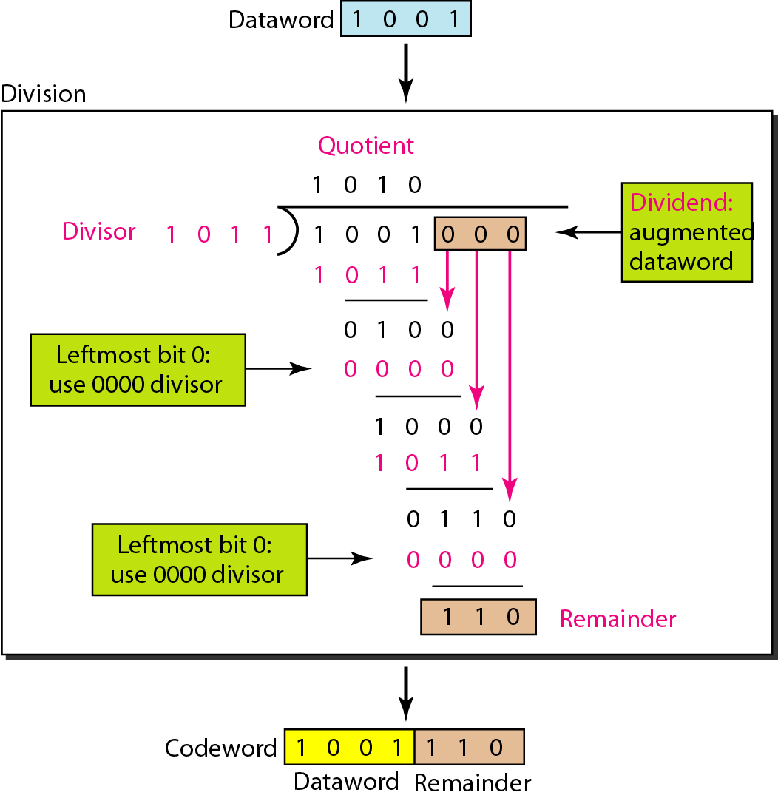

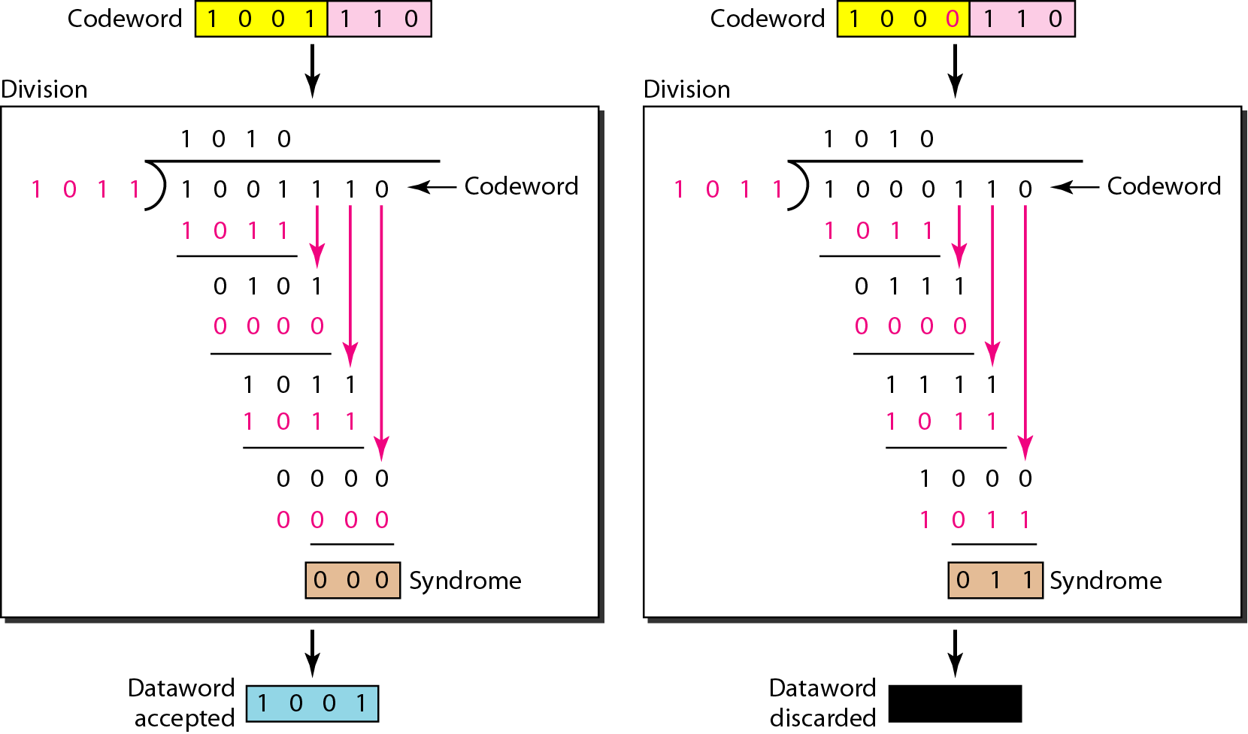

***Division in the CRC decoder for two cases***

**PROGRAM:**

#include<stdio.h>

#include<string.h>

#define N strlen(g)

char t[10],cs[10],g[]="1011";

int a,e,c;

void xor(){

for(c = 1;c < N; c++)

cs[c] = (( cs[c] == g[c])?'0':'1');

}

void crc(){ for(e=0;e<N;e++)

cs[e]=t[e]; do{

if(cs[0]=='1')

xor(); for(c=0;c<N-1;c++)

cs[c]=cs[c+1];

cs[c]=t[e++];

}while(e<=a+N-1);

}

int main()

{

printf("\nEnter data : "); scanf("%s",t);

printf("\n----------------------------------------");

printf("\nGeneratng polynomial : %s",g); a=strlen(t);

for(e=a;e<a+N-1;e++) //append zeros to the dataword t[e]='0';

printf("\n----------------------------------------");

printf("\nModified data is : %s",t);

printf("\n----------------------------------------");

crc(); //perform crc printf("\nChecksum is : %s",cs); for(e=a;e<a+N-1;e++)

t[e]=cs[e-a];

printf("\n----------------------------------------");

printf("\nFinal codeword is : %s",t); printf("\n----------------------------------------");

printf("\nTest error detection 0(yes) 1(no)? : "); scanf("%d",&e);

if(e==0)

{

do{

printf("\nEnter the position where error is to be inserted : "); scanf("%d",&e);

}while(e==0 || e>a+N-1); t[e-1]=(t[e-1]=='0')?'1':'0';

printf("\n----------------------------------------");

printf("\nErroneous data : %s\n",t);

}

crc();

for(e=0;(e<N-1) && (cs[e]!='1');e++); if(e<N-1)

printf("\nError detected\n\n"); else

printf("\nNo error detected\n\n");

printf("\n----------------------------------------\n");

return 0;

}

A CRC is constructed to generate a 3 bit FCS for a 4-bit message. The generator pattern is 1011.

1. Show the generation of the codeword at the sender site
2. Show the checking of the codeword at the receiver site (assume no error).
3. Show that the detection algorithm detects error if received codeword is corrupted.

#### RESULT & INFERENCES:

Dataword: k Codeword: n Divisor: n-k+1

Augment n-k zeros to dataword

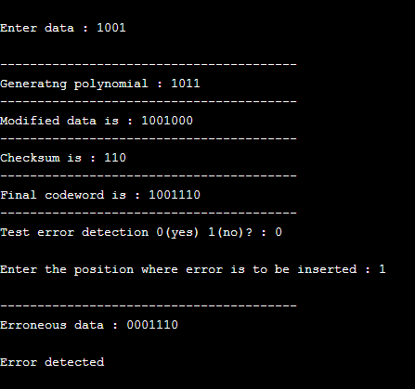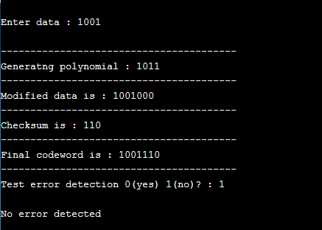

* + A **cyclic redundancy check** (**CRC**) is an [error-detecting code](https://en.wikipedia.org/wiki/Error_detection_and_correction) commonly used in digital [networks](https://en.wikipedia.org/wiki/Telecommunications_network) and storage devices to detect accidental changes to raw data.
  + Blocks of data entering these systems get a short *check value* attached, based on the remainder of a [polynomial division](https://en.wikipedia.org/wiki/Polynomial_long_division) of their contents.
  + On retrieval, the calculation is repeated and, in the event the check values do not match, corrective action can be taken against data corruption. CRCs can be used for [error correction](https://en.wikipedia.org/wiki/Error_correcting_code)
  + CRCs are so called because the *check* (data verification) value is a *redundancy* (it expands the message without adding [information](https://en.wikipedia.org/wiki/Entropy_(information_theory))) and the [algorithm](https://en.wikipedia.org/wiki/Algorithm) is based

on [*cyclic* codes.](https://en.wikipedia.org/wiki/Cyclic_code)

#### Result:

The above experiment was successfully executed and output verified.

## Experiment No: 7

#### COMPUTER COMMUNICATION LAB

**Implementation of Bit Stuffing/De-stuffing and Byte Stuffing/De-stuffing to delimit MAC frames using ‘C’ Program**

**Name : Debasya Sahoo**

**Reg. No : 15BEC1111**

**AIM:**

1. **To Implement Bit Stuffing/De-stuffing using C programming language**
2. **To Implement Byte Stuffing/De-stuffing using C programming language and understand the importance of Character oriented and Bit Oriented Protocols and need for stuffing MAC frames.**

**SOFTWARE USED:**

C Programming Language, Turbo C/C++ compiler or gcc compiler (Linux)

#### PROCEDURE:

Bit stuffing is the process of adding one extra 0 whenever five consecutive 1s follow a 0 in the data, so that the receiver does not mistake the pattern 0111110 for a flag.

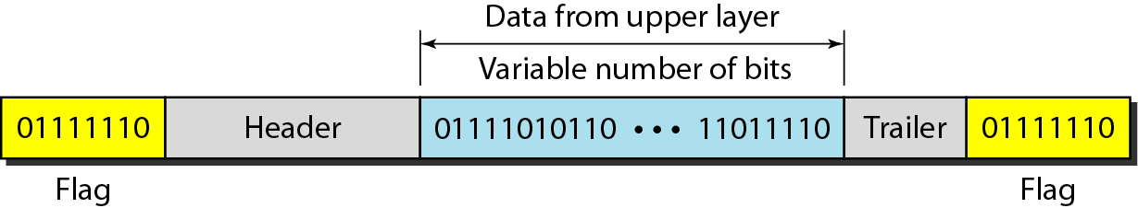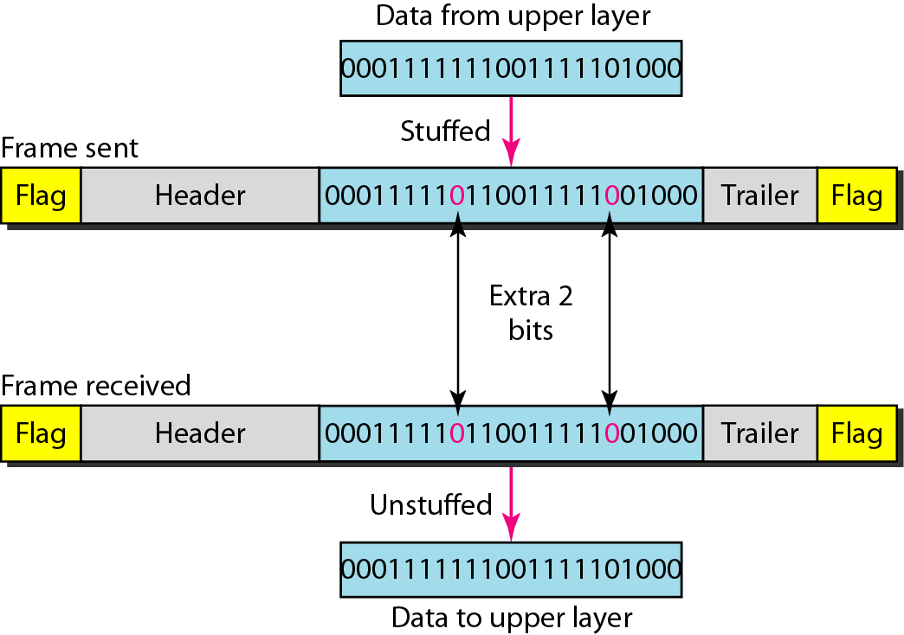

Byte stuffing is the process of adding 1 extra byte whenever there is a flag or escape character in the text.

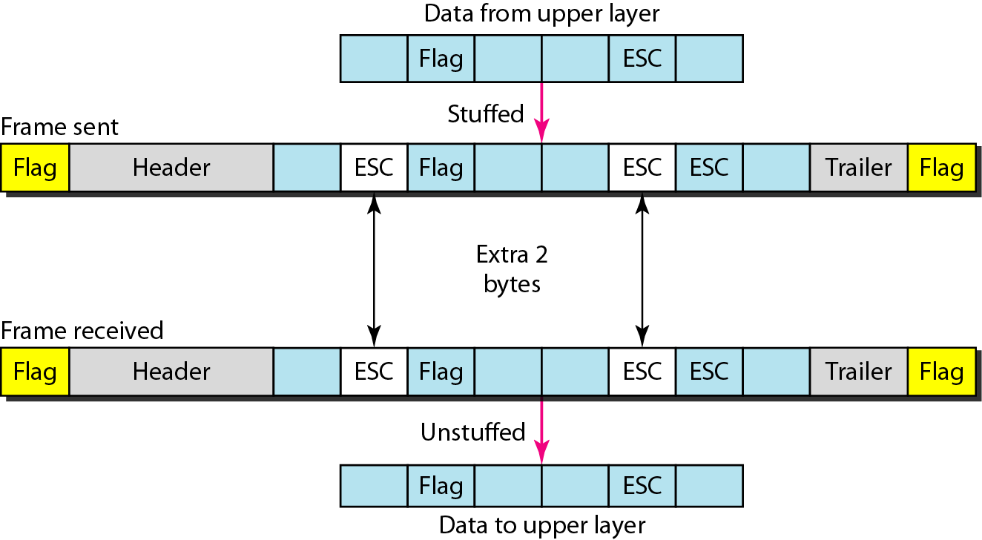

Byte Stuffing

#include <stdio.h>

#include <string.h> intmain()

{

char s1[50], stuf[50], dstuf[50]; inti, j=0;

printf("Enter Data Frame: "); scanf("%s", s1);

for(i=0;i<=strlen(s1);i++)

{

if(s1[i]=='#' || s1[i]=='$')

{

stuf[j]='#'; j++;

}

stuf[j]=s1[i]; j++;

}

printf("%s\n",stuf); j=0;

for(i=0;i<=strlen(stuf);i++)

{

if(stuf[j]=='#')

{

dstuf[i]=stuf[j+1]; j=j+2;

}

else

{

dstuf[i]=stuf[j]; j++;

}

}

printf("%s",dstuf);

return 0;

}

Output:

1. If both Flag and ESC is part of data

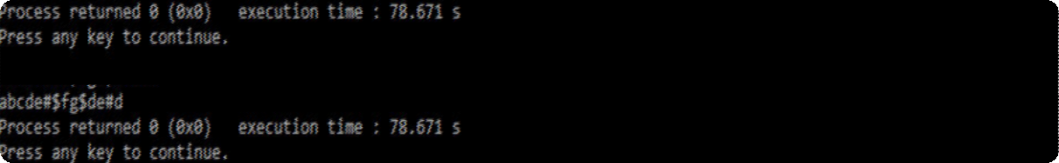

1. Either no flag or esc character in frame- no stuffing

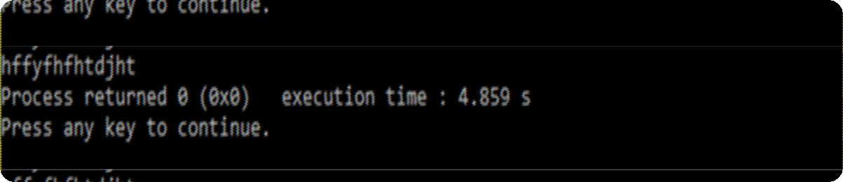

1. If flag is part of frame, stuff '#' before '$'

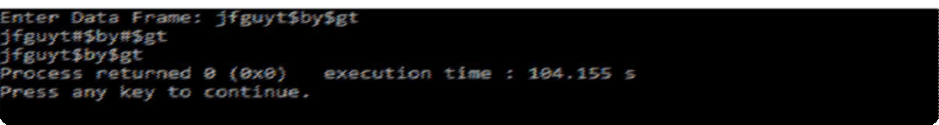

1. If ESC is part of frame, stuff '#' before '#'

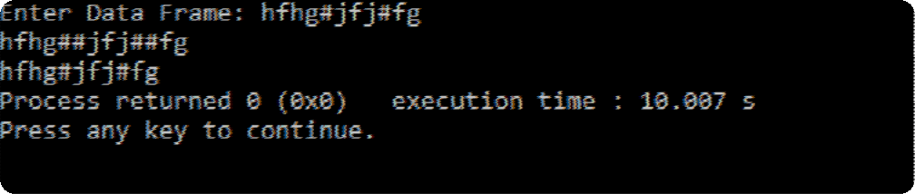

## Bit Stuffing

#include<stdio.h>

#include<stdlib.h>

intmain()

{

char *p,*q; char t;

char in[50],stuf[50],dstuf[50];

int c=0;

printf("input data Frame data: "); scanf("%s",in);

p=in; q=stuf;

while(*p!='\0')

{

if(*p=='0')

{

*q=*p; q++; p++;

}

else

{

while(*p=='1' && c!=5)

{ c++;

*q=*p; q++; p++;

}

if(c==5)

{

if(*(q-6)=='0'){

*q='0'; q++;

}

} c=0;

}

}

*q='\0';

printf("\nStuffed data frame: "); printf("%s",stuf);

p=stuf; q=dstuf; while(*p!='\0')

{

if(*p=='0')

{

*q=*p; q++; p++;

}

else

{

while(*p=='1' && c!=5)

{ c++;

*q=*p; q++; p++;

}

if(c==5)

{

p++;

} c=0;

}

}

*q='\0';

printf("\ndestuffed data frame: "); printf("%s\n",dstuf);

return 0;

}

Output:

a) 00000000000000000000000000000000

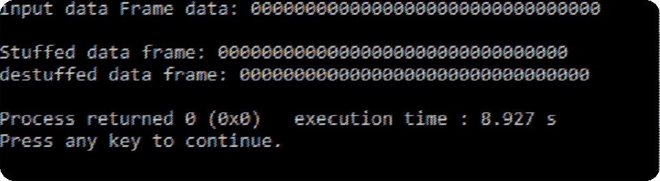

b) 111111111111111111111111111

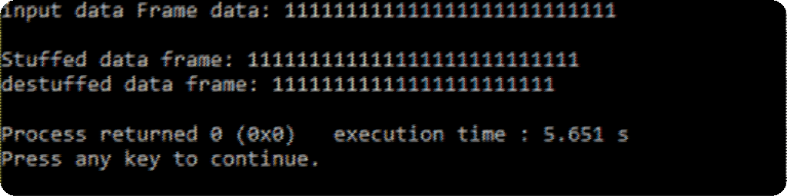

c) 01111100001111111111111011111

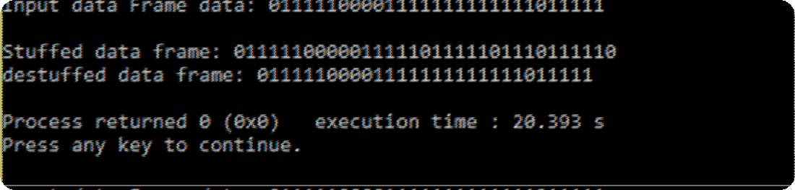

d) 011111111111000000000111110

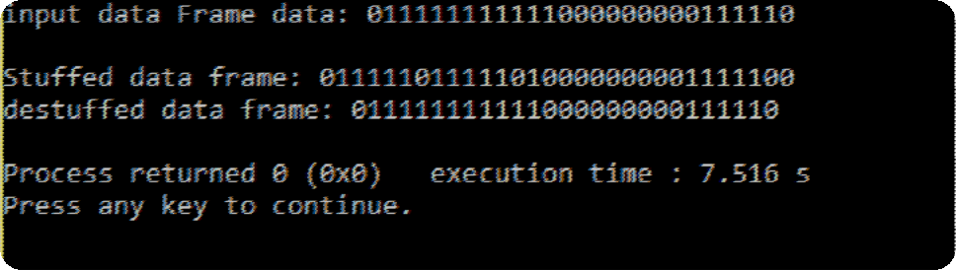

Inference:

1. In case of when text contains one or more escape characters followed by a flag. To solve this problem, the escape characters that are part of the text are marked by another escape character i.e., if the escape character is part of the text, an extra one is added to show that the second one is part of the text.
2. Bit stuffing cannot be done if we only get 5 consecutive 1 it applicable only if whenever we encounter 11111(5 ones) after a 0 we would insert 0 in the data after 011111 0

Result: Hence, we successfully implemented of Bit Stuffing/De-stuffing and Byte Stuffing/De-stuffing to delimit MAC frames using ‘C’ Program

## EXPERIMENT 8

**COMPUTER COMMUNICATION LAB**

**NAME**: Debasya Sahoo

**REG NO**-15BEC1111

## Study and Analysis the Performance of CSMA/CA and CSMA/CD using NETSIM

### **Aim:** To study the performance of a CSMA/CA, by changing the number of the network nodes , using NetSim and plotting the graph using excel.

#### ONLY 2 NODES:

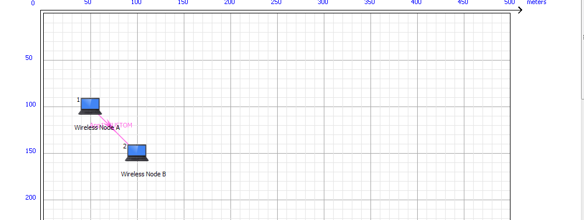

**DELAY AND THROUGHPUT:**

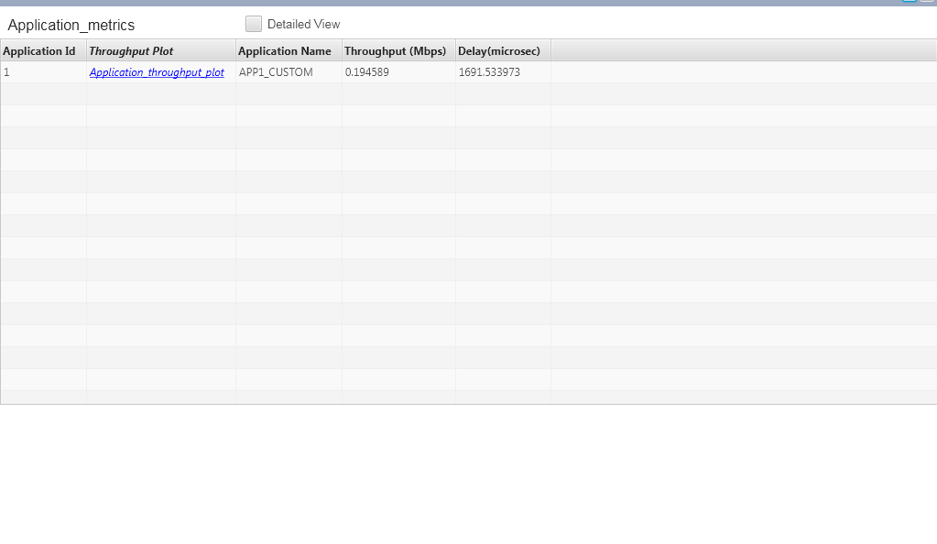

#### NODES:

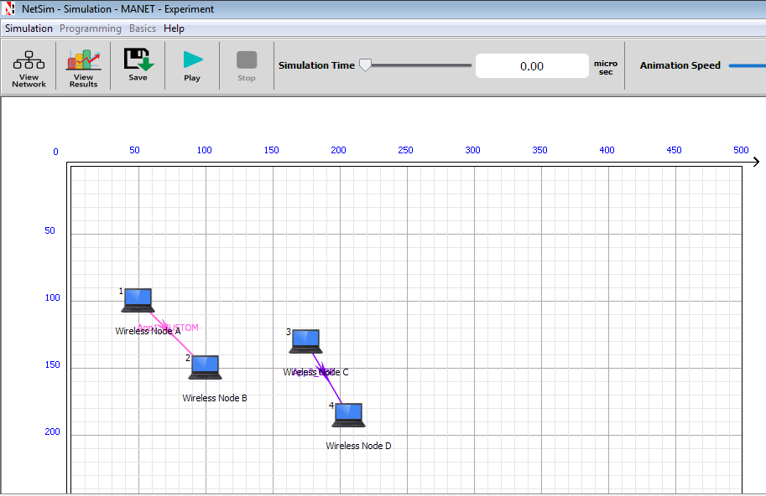

**DELAY AND THROUGHPUT**

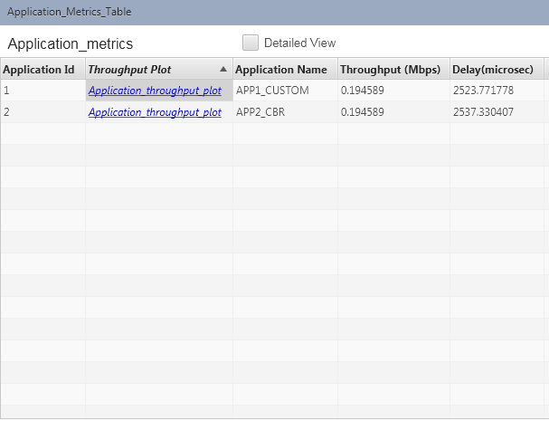

AVG THROUGHPUT: 0.1945Mbps AVG DELAY: 2530.55 ms

**6 NODES:**

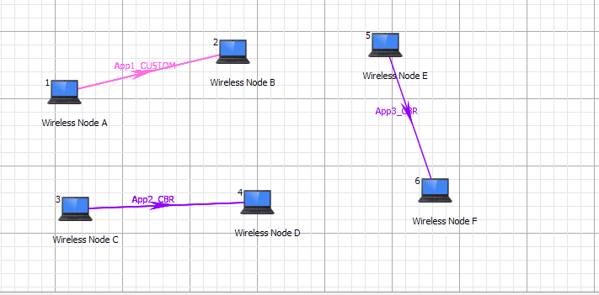

**DELAY AND THROUGHPUT**

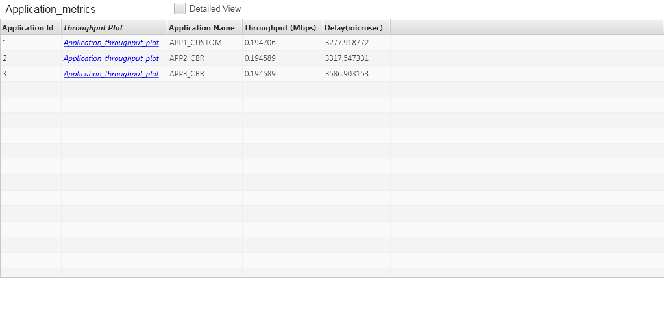

AVG THROUGHPUT:0.1945Mbps AVG DELAY:3394.16ms

PLOT OF THORUGHPUT VS NODES:

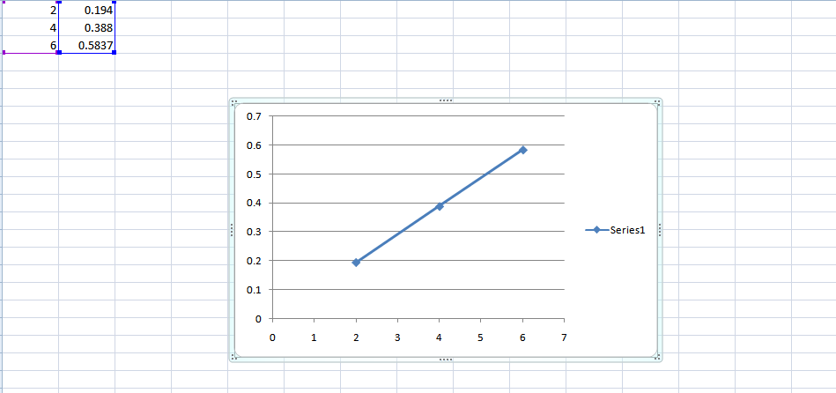

PLOT OF DELAY VS NODES:

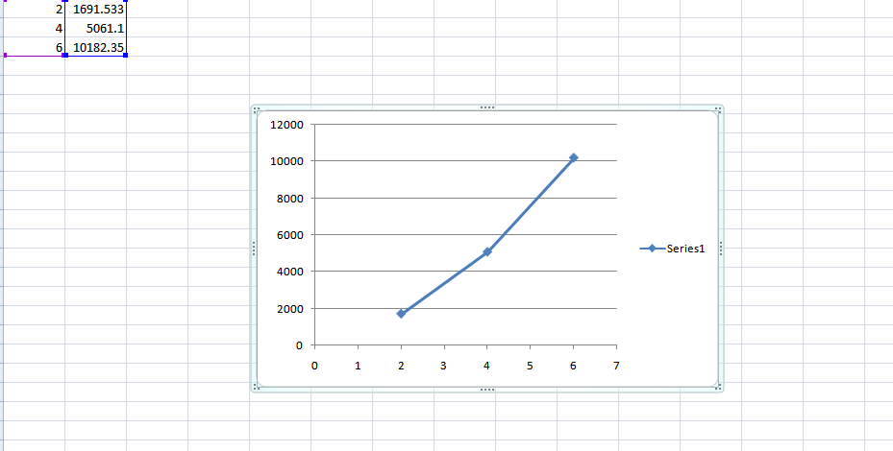

## Study and Analysis the Performance of CSMA/CD using NETSIM

### **Aim:** To study the performance of a CSMA/CD, by changing various factors of the network, using NetSim.

Different Factors are

* Increasing the persistance value with fixed number of nodes and applications.
* Increasing the number of application traffics (light load to heavy load)

**Network Simulation Specifications:**

1. No of Nodes = 10 ; Set Destination Node = 0 (for broadcast) ; No of Applications (CBR) = 10; Inter-arrival Time : 1000ms; uplink and downlink bit error rate = 0; persistance value= 1 (vary the values:1/2, 1/3, 1/4, 1/5,1/6,1/7,1/8,1/9 1/10, 1/11)

Only UDP sources ; Dynamic ARP enabled ; Simulation time : 10seconds

* + **Inference (Plots):** Calculate the Average Application Throughput vs Persistance value.

### No of Nodes = 10; Packet Inter-arrival Time = 2500ms ; Increase the number of Application Traffics (nodes in this case) = 1, 2, 3, 5, 7 ; No of Destination Node = 1 (node 9 ) ; Link Speed = Switch to Destination = 10Mbps (Duplex)

* + **Inference (Plots):**
  + Calculate the Total Packets Errored vs No of Application Traffics
  + Calculate the Average Application Throughput vs No of Application Traffic/Nodes and draw the comparison graph for different number of transmission.

#### SOLUTION 1:

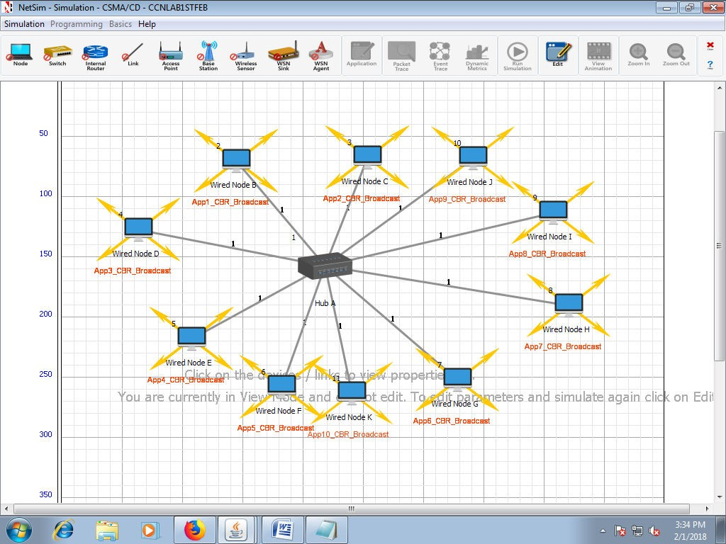

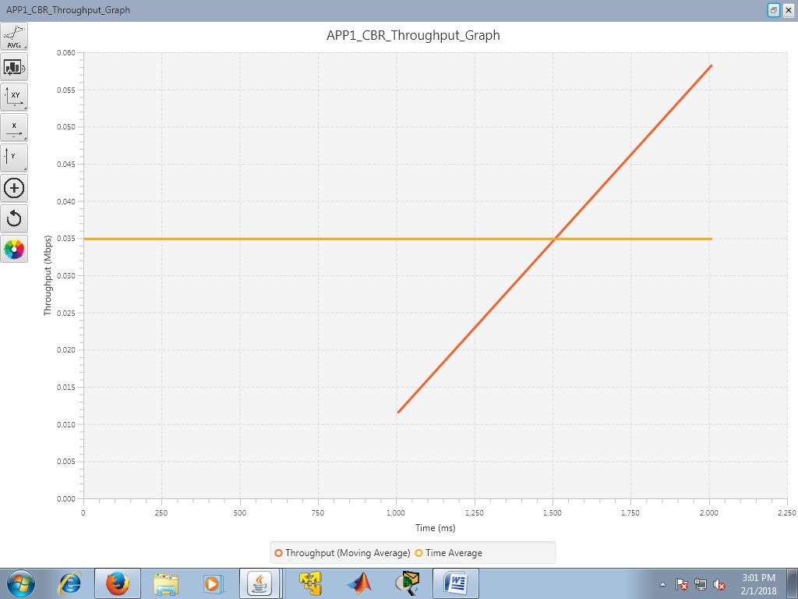PERSISTENCE=1,THROUGHPUT=0.035

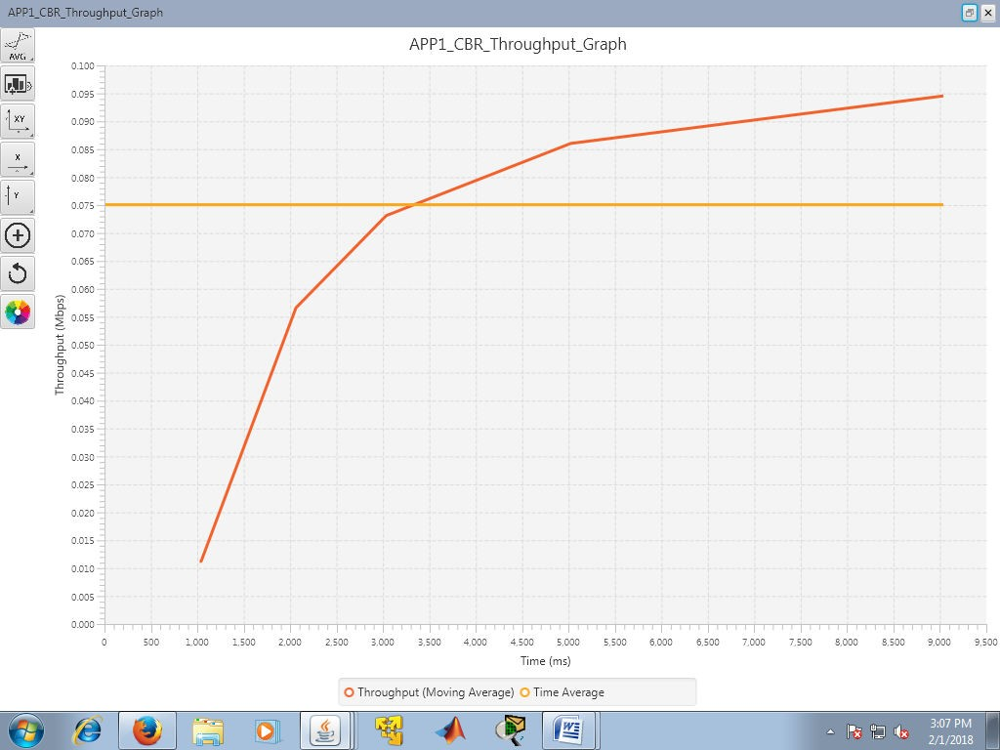PERSISTENCE=1/2,THROUGHPUT=0.075

PERSISTENCE=1/3,THROUGHPUT=0.076

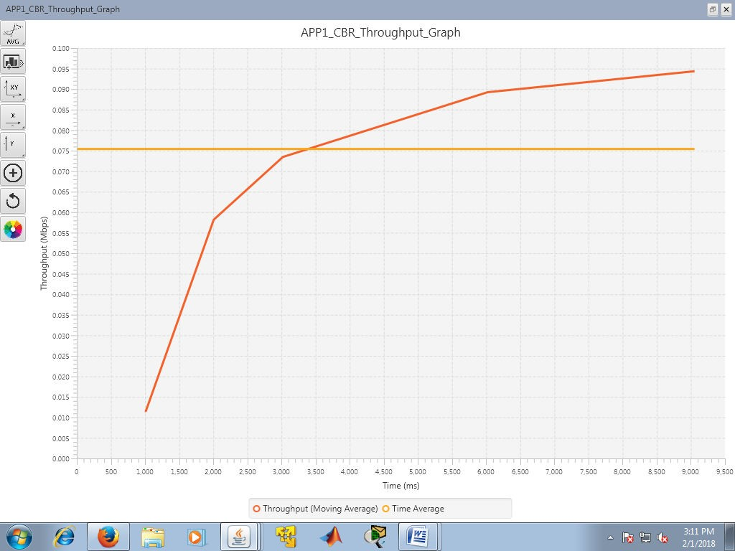

PERSISTENCE=1/4,THROUGHPUT=0.0754

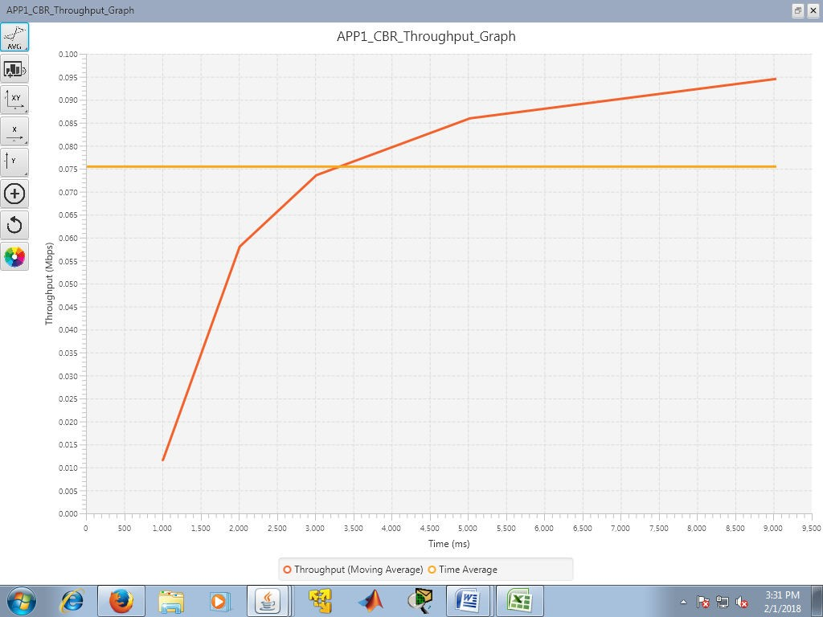

PERSISTENCE=1/5,THROUGHPUT=0.076

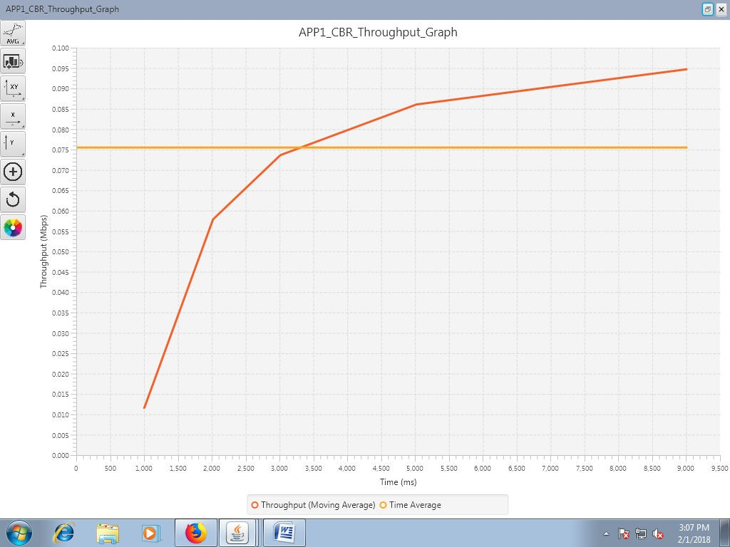

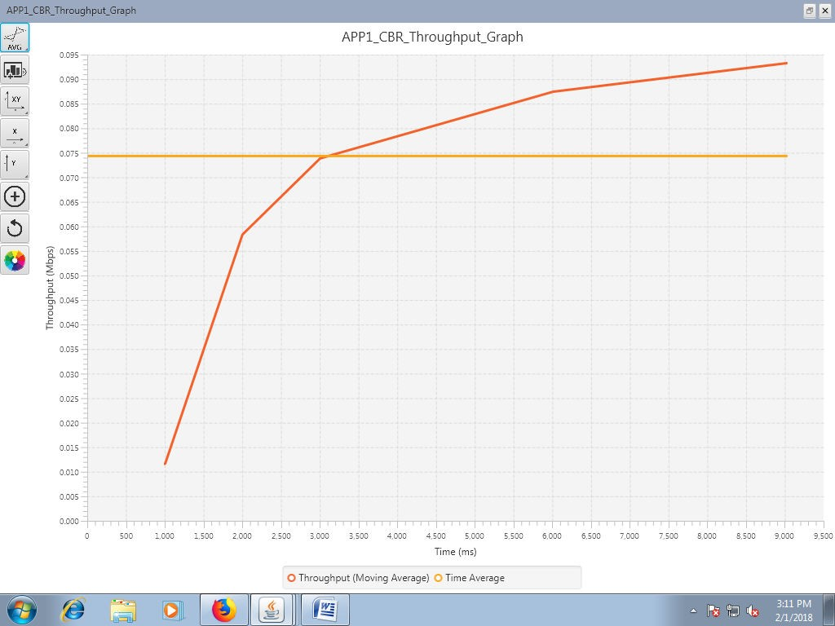PERSISTENCE=1/6,THROUGHPUT=0.0743

PERSISTENCE=1/7,THROUGHPUT=0.0738

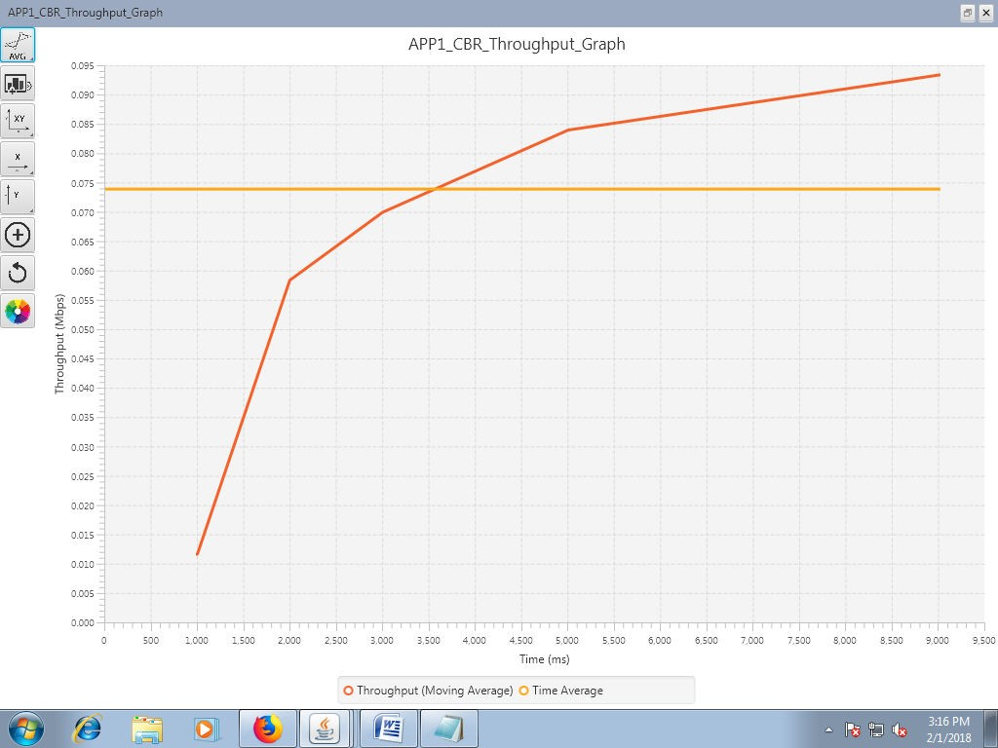

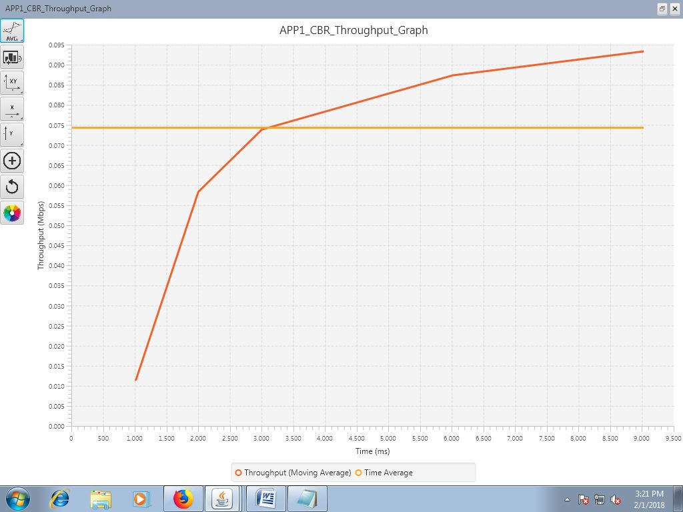PERSISTENCE=1/8,THROUGHPUT=0.0747

#### AVERAGE THROUGHPUT VS PERSISTENCE GRAPH:

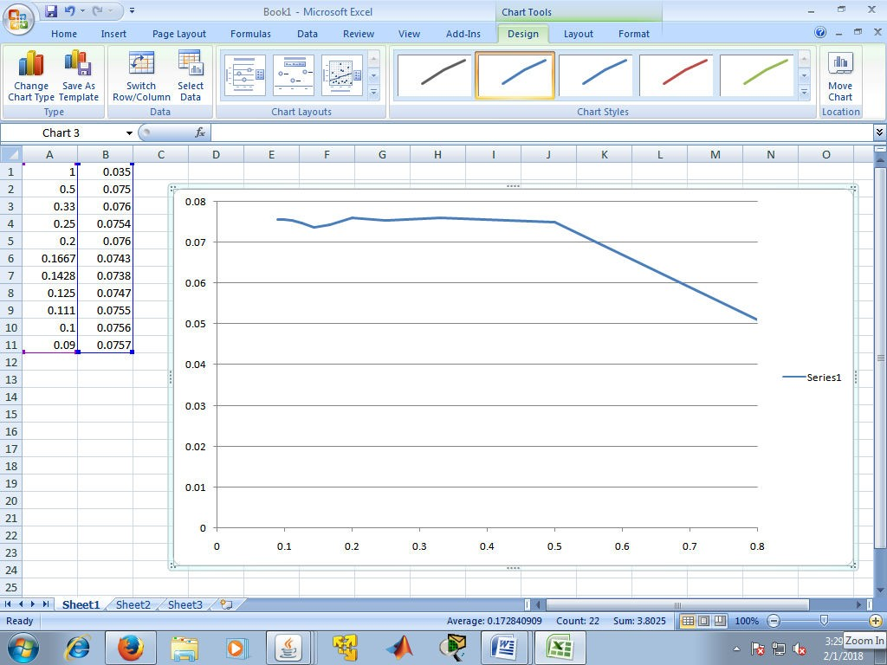

solution 2:

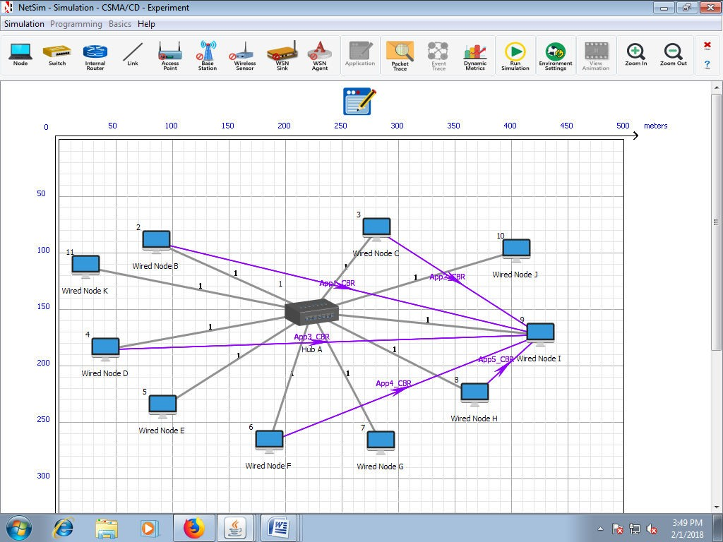

Network Matrix

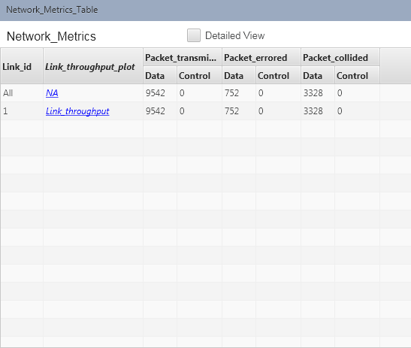

THROUGHPUT VS APPLICATION ID

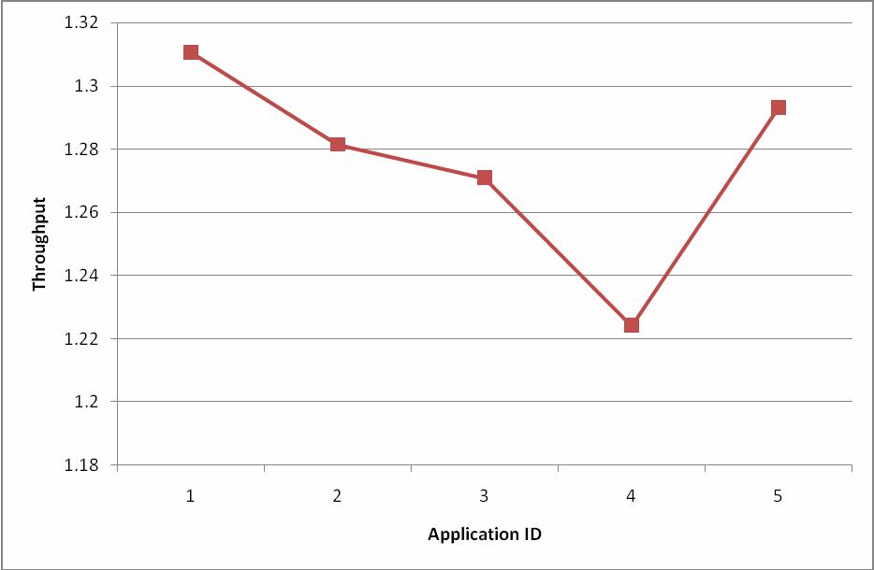

**RESULTS** : Experiment is successfully verified using NetSim

## Experiment 9

**Computer Communication Lab**

**Name :** Debasya Sahoo

**Reg.** **:**15BEC1111

### **Aim:** To study Hidden Node Problem with and without RTS/CTS in WLAN.

**Device connection:**

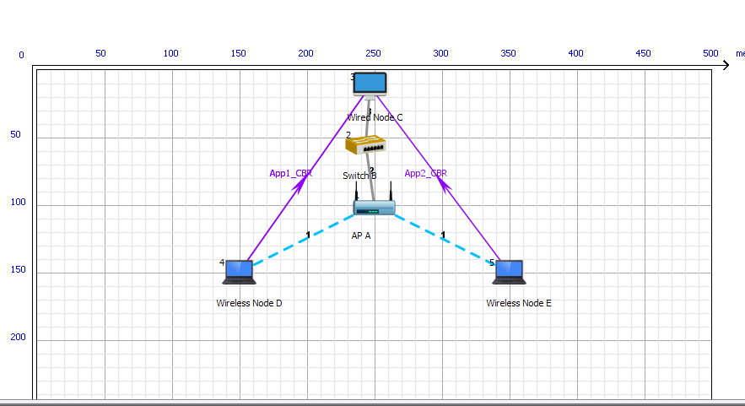

**Simulation Results:**

**Sample 1:**

**Application Metrics - Average throughput**

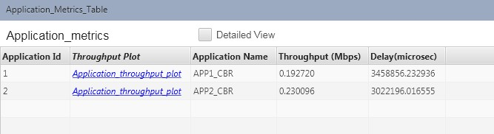

**Network Metrics- Packets collided:**

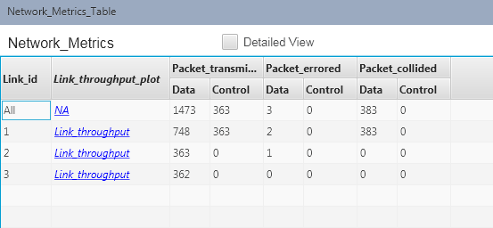

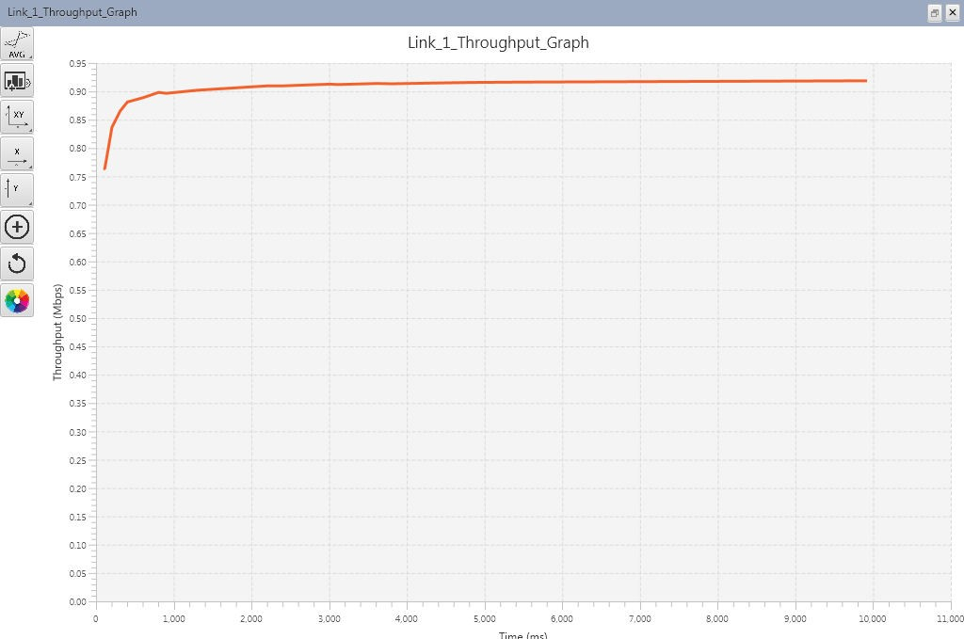

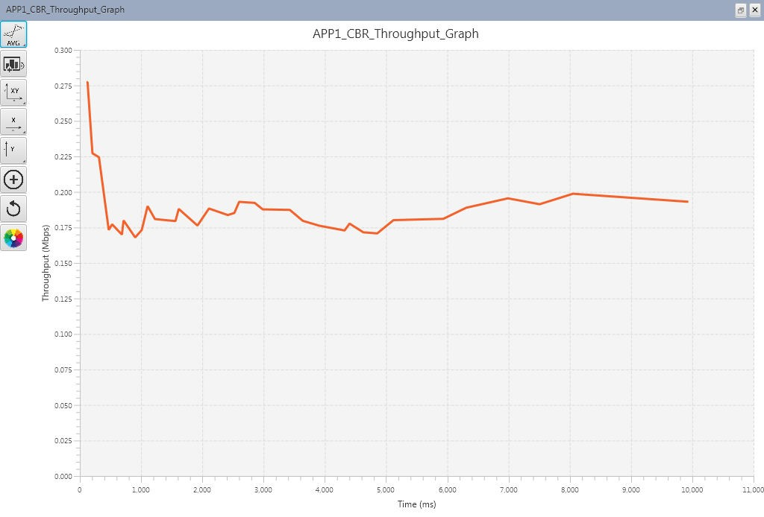

**Sample 2:**

**Application metrics- Average throughput:**

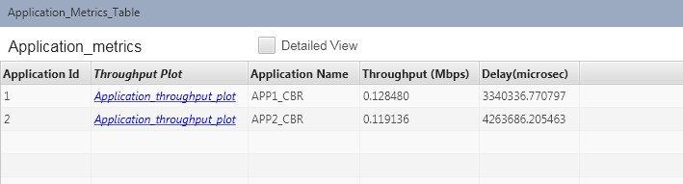

**Network metrics- Packets collided:**

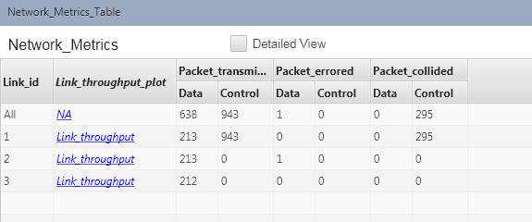

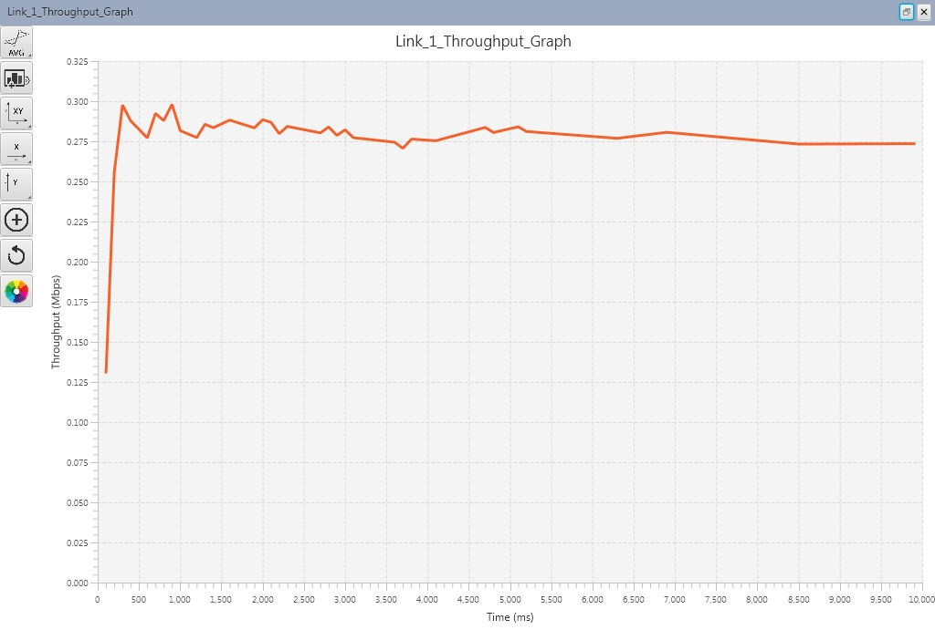

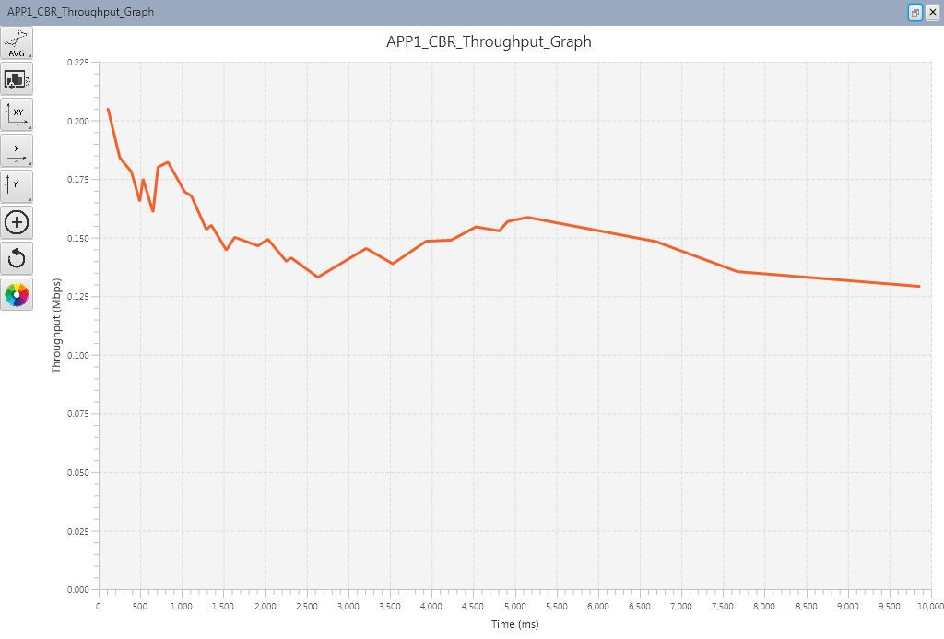

**Observation:**

**Packets Collision:**

|  |  |  |
| --- | --- | --- |
| **Collided packets** | **Sample 1(Without**  **RTS/CTS)** | **Sample 2(With RTS/CTS)** |
| **Data packets** | 383 | 0 |
| **Control Packets** | 0 | 295 |

**Average throughput:**

|  |  |  |
| --- | --- | --- |
| **Metrics(Throughput in Mbps)** | **Sample 1(Without RTS/CTS)** | **Sample 2(With RTS/CTS)** |
| **Application 1** | 0.1927 | 0.1284 |
| **Application 2** | 0.2300 | 0.1191 |

**Inference:**

The comparison with hidden stations shows that RTS/CTS mechanism reduces the data packet collision.

In sample 1 due to hidden node problem, packets collide continuously. In sample 2 on enabling RTS/CTS, the source node will refrain from sending a data frame until it completes a RTS/CTS handshake with another station, such as an access point. A station initiates the process by sending a RTS frame. The access point receives the RTS and responds with a CTS frame. The station must receive a CTS frame before sending the data frame. The CTS also contains a time value that alerts other stations to hold off from accessing the medium while the station initiating the RTS transmits its data. Hence in RTS/CTS mechanism throughput of

the applications are less than the other sample. Because data packets are transmitted after the successful RTS/CTS handshake happened.

**Experiment No: 10**

**Implementation of Dijkstra Algorithm using C**

**Name :** Debasya Sahoo

**Reg. No:** 15BEC1111

### **AIM:** Implementation of Dijkstra Algorithm – Shortest Path Tree Computation using C

**SOFTWARE USED:**

C Programming Language (DEV C)

**ALGORITHM: INPUT:**

1. **Input the Number of Nodes in the Graph (N)**
2. **Input the 2-D Matrix Link State Database (lsdb[N][N]) or Adjacency Matrix (in Graph Theory Terms) of Size N*N.**
   1. **Weight of the edges – represent the link cost**
   2. **If node is not adjacent neighbor, mark the link cost to infinity (say 999 means unreachable directly) in the Adjacency Matrix**
   3. **Link cost of Node to itself is 0.**
3. **Input the Root Node out of N nodes which computes the Shortest path Tree (running Dijkstra’s)**

**OUTPUT:**

**1) Output a 1-D Array say D[] of size N whose values represents the least cumulative cost for root node to reach to every other node in the network.**

**Input Graph (V,E)**

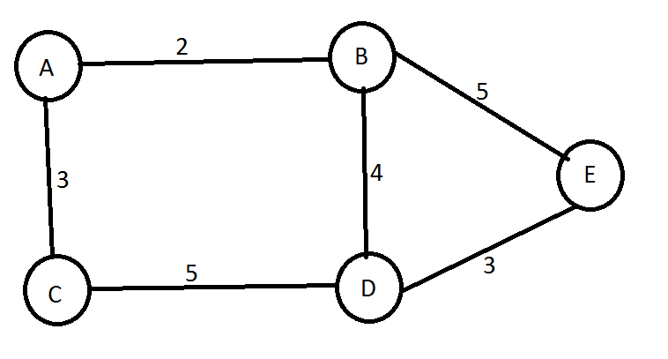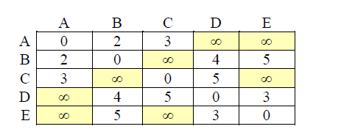

**Output :**

**Say Root Node is ‘A’ (say A is node index 0, B is node index 1 etc..)**

# Output D[] array values :

**D[0] = 0 ; D[1] = 2 ; D[2] = 3 ; D[3] = 6 ; D[4]= 7**

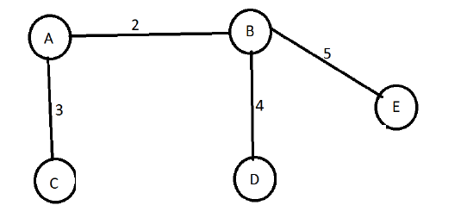

**ALGORITHM**

**Initialization**

1. **Initialize D[] values with D[i] = lsdb[root][i] (Pick the row of the root node from the adjacency matrix) ( i** ∀ N)
2. **Initialize flag[i] array to 0 for all N nodes**

## To track whether node is processed or unprocessed.

* 1. **[Processed means – node is visited and the least cumulative cost is calculated]**
  2. **If processed, value will be changed to 1**

1. **Track two lists Permanent List and Tentative List via flag[i] array.**

* **Permanent list are the list of nodes processed whose shortest (least) cumulative cost is calculated and nodes are marked as flagged (flag[i]=1)**
* **Tentative – unprocessed – nodes unmarked**

1. **Start with the root node (which was in tentative list) and move it to permanent list & set flag[root]=1**
2. **Among the unprocessed neighbors of root node and find the node ‘w’ with D[w] minimum among all nodes and put that node in permanent list.**
3. **For every node x which is a neighbor of w and not in permanent list ,**

**find the cumulative cost to reach x via node w D[x] = D[w]+ lsdb[w][x]**

## and if D[x] value is smaller than it’s existing value then update the D[x] value.

**i.e D[x] = min{D[x],D[w]+lsdb[w][x]}.**

## Find the node x with min D[x] and put that in permanent list

1. **Repeat step 6 until there is no node left in tentative list, i.e. all f[i] ==1.**
2. **Print the cumulative cost of each node w.r.t. to root node i.e print the values of D[] array**

#### Code:

#include<stdio.h>

#define infinity 999

/*void dijkstra(int num, int root, int lsdb[10][10], int D[10]){

}*/

int min(int a, int b){ int min=0; if(a<b){

return a;

}else{

return b;

}

}

int main(){

int num,root, lsdb[10][10], D[10], flag[10]; int x,i,j,k,w;

printf("enter the number of nodes"); scanf("%d",&num);

printf("enter the root node"); scanf("%d", &root); printf("Enter the lsdb matrix"); for(i=0;i<num;i++){

for(j=0; j<num;j++){ scanf("%d", &lsdb[i][j]);

}

}

for(i=0;i<num;i++){ D[i]= lsdb[root][i];

}

printf("Initial root row:"); for(i=0;i<num;i++){

printf("%d\t", D[i]);

}

for(k =0;k<num;k++){ flag[i]=0;

}

for(x=0;x<num;x++){ for(w=0;w<num;w++){ D[x]=min(D[x],D[w]+lsdb[w][x]);

}

}

printf("\nFinal row:\n"); for(i=0;i<num;i++){

printf("%d\t", D[i]);

}

//dijkstra(num,root,lsdb,D); getchar();

return 0;

}

Out put

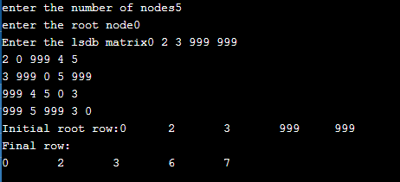

**Experiment 11**

**Simulation and Analysis of TCP Congestion Control Mechanism in Ns2**

***Name: Debasya Sahoo Registration Number: 15BEC1111***

**AIM:**

To simulate the TCP congestion control mechanism in NS2 and analyze the different phases of TCP on adaptive data rate control to control network congestion.

**SOFTWARE USED:**

Network Simulator (NS2), 2.35 version.

**THEORY:**

Network Simulator

A package of tools that simulates behaviour of networks: Create network topologies.

Log events that happen under any load.

Analyze events to understand the network behaviour.

Network Animator (NAM)

A visual aid showing how packets flow along the network.

**STEPS FOR EXECUTION:**

* Initialise a simulator class.
* Define the nodes.
* Queuing of the models.
* Topology is defined.
* Define the agents.
* Stack agents and applications.
* Execute the visualization to see how definition is going by NAM.
* Performance analysis by trace.
* Post analysis using tracegraph

**PROCEDURE:**

3 phases

* Slow-Start Phase
  + Sender starts with very slow rate of transmission
  + Increases rapidly till threshold
* Congestion Avoidance
  + When Threshold reached, Reduce Data rate to avoid congestion
* Congestion Detection
  + Sender goes back to Slow Start / Congestion Avoidance phase depending on how congestion is detected

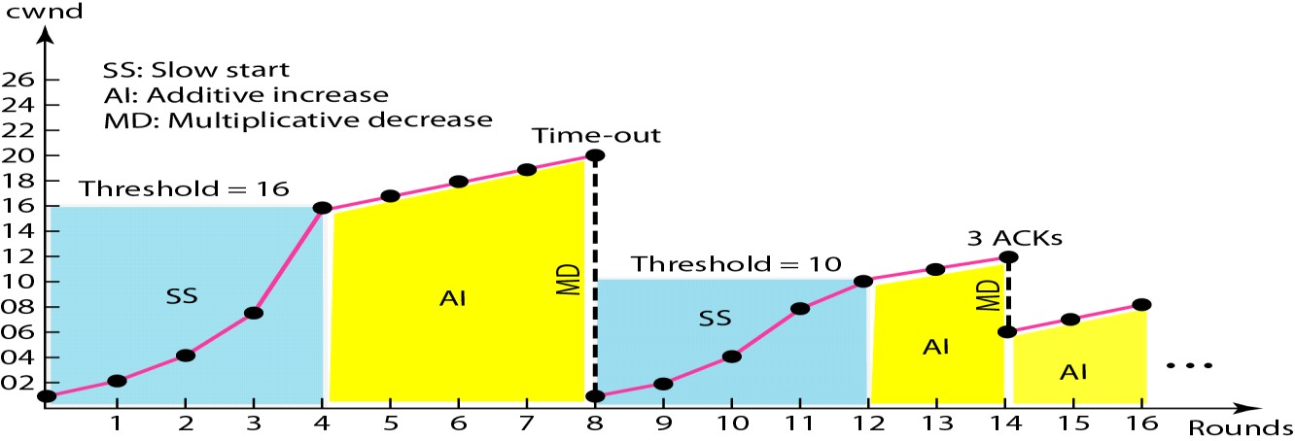

**CODING**

# Create an object of Simulator Class set ns [new Simulator]

#Create NAM and trace file set nf [open congestion.nam w]

$ns namtrace-all $nf

set tf [open congestion.tr w]

$ns trace-all $tf

$ns color 1 Blue

$ns color 2 Red

#Create Nodes

set n0 [$ns node] set n1 [$ns node] set n2 [$ns node] set n3 [$ns node]

#Create Links

$ns duplex-link $n0 $n2 2Mb 10ms DropTail

$ns duplex-link $n1 $n2 2Mb 10ms DropTail

$ns duplex-link $n2 $n3 1.2Mb 20ms DropTail

$ns duplex-link-op $n0 $n2 orient right-down

$ns duplex-link-op $n1 $n2 orient right-up

$ns duplex-link-op $n2 $n3 orient right

$ns duplex-link-op $n2 $n3 queuePos 0.5

#Create transport agents set tcp [new Agent/TCP]

$ns attach-agent $n0 $tcp

$tcp set class_ 1

set sink [new Agent/TCPSink]

$ns attach-agent $n3 $sink

$ns connect $tcp $sink set udp [new Agent/UDP]

$udp set class_ 2

$ns attach-agent $n1 $udp set null [new Agent/Null]

$ns attach-agent $n3 $null

$ns connect $udp $null

#Create Application Traffic

set cbr [new Application/Traffic/CBR]

$cbr set packetSize_ 1000

$cbr set rate_ 1Mb

$cbr attach-agent $udp

set ftp [new Application/FTP]

$ftp attach-agent $tcp

#Default setting in ns2 - ssthresd_ 20

set outfile [open congestion.txt w]

proc plotWindow {tcpSource outfile} { global ns

set now [$ns now]

set cwnd [$tcpSource set cwnd_] puts $outfile "$now $cwnd"

$ns at [expr $now+0.1] "plotWindow $tcpSource $outfile"

}

$ns at 1.0 "plotWindow $tcp $outfile"

# Schedule traffic

$ns at 0.1 "$cbr start"

$ns at 1.0 "$ftp start"

$ns at 20.0 "$ftp stop"

$ns at 20.5 "$cbr stop"

$ns at 20.6 "finish"

proc finish {} { global ns nf tf

$ns flush-trace close $nf

close $tf

exec nam congestion.nam & exit 0

}

#Finish and run

$ns run

**Sample OUTPUT**

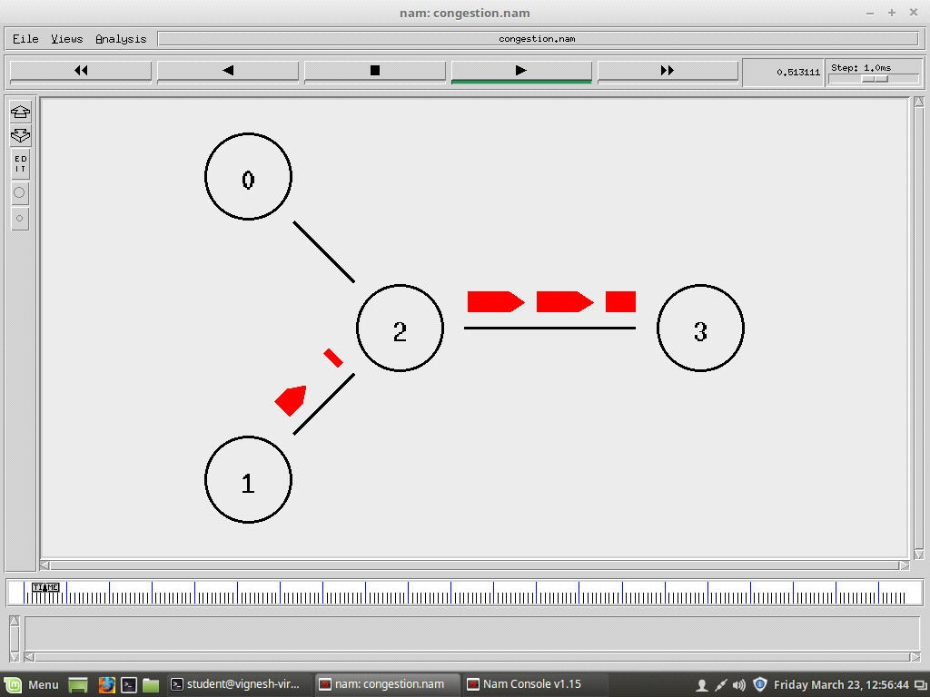

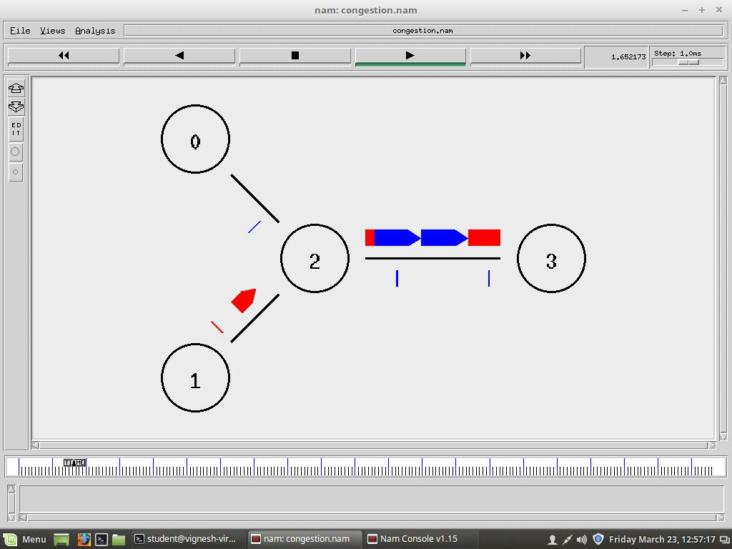

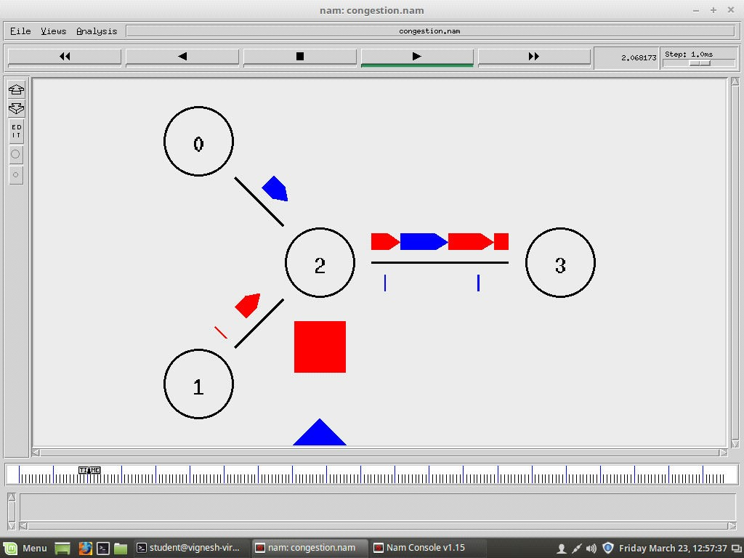

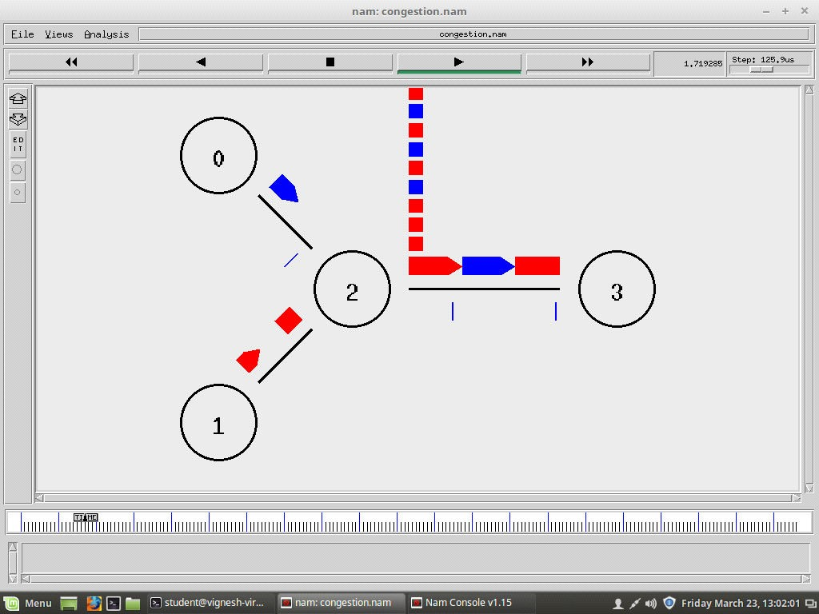

**RECORD THE INFERENCES & RESULTS**

* TCP uses a congestion window and a congestion policy that avoid congestion.
* If the network cannot deliver the data as fast as it is created by the sender, it must tell the sender to slow down, i.e. in addition to the receiver, the network is a second entity that determines the size of the sender’s window.
* Congestion policy in TCP –
* **Slow Start Phase:** starts slowly increment is exponential to threshold
* **Congestion Avoidance Phase:** After reaching the threshold increment is by one. That is there is linear increment.
* **Congestion Detection Phase:** Sender goes back to Slow start phase or Congestion avoidance phase.

**Node analysis and PDR calculations using tracegraph and grep commands:**

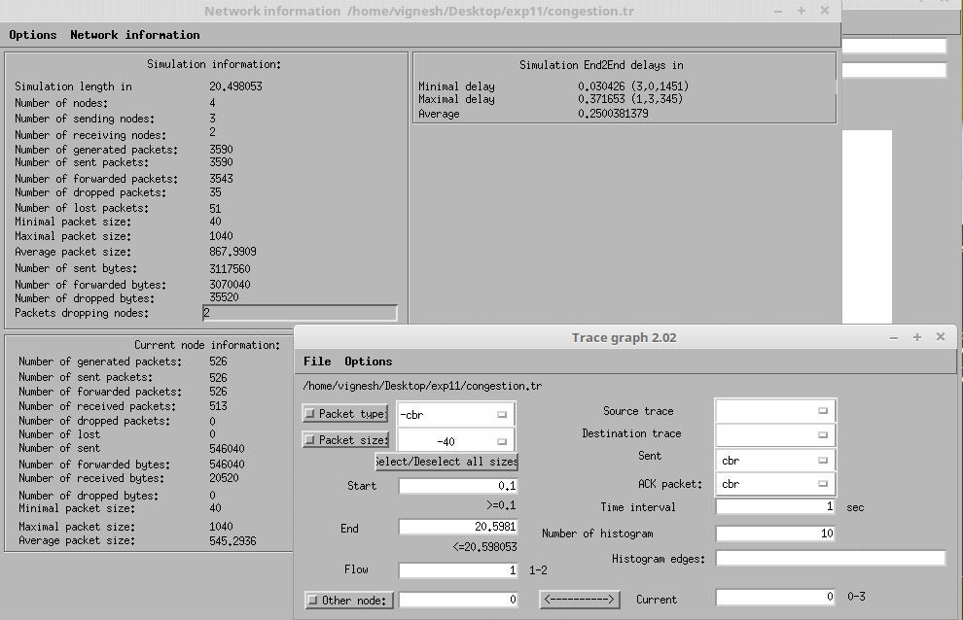

PDR (0-3) TCP packets = 513/526 = 97.52%

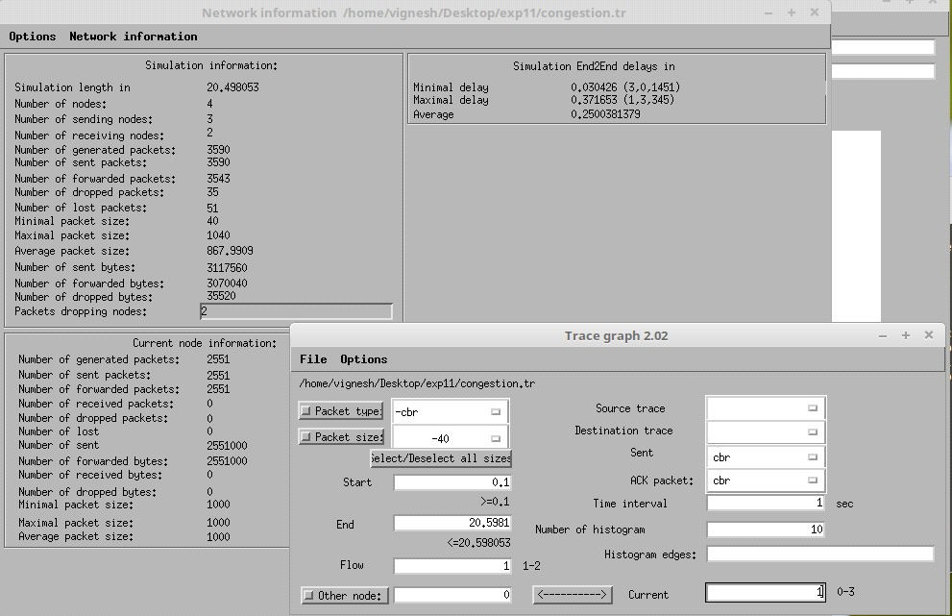

PDR (1-3) UDP packets = 2551/2551 = 100%

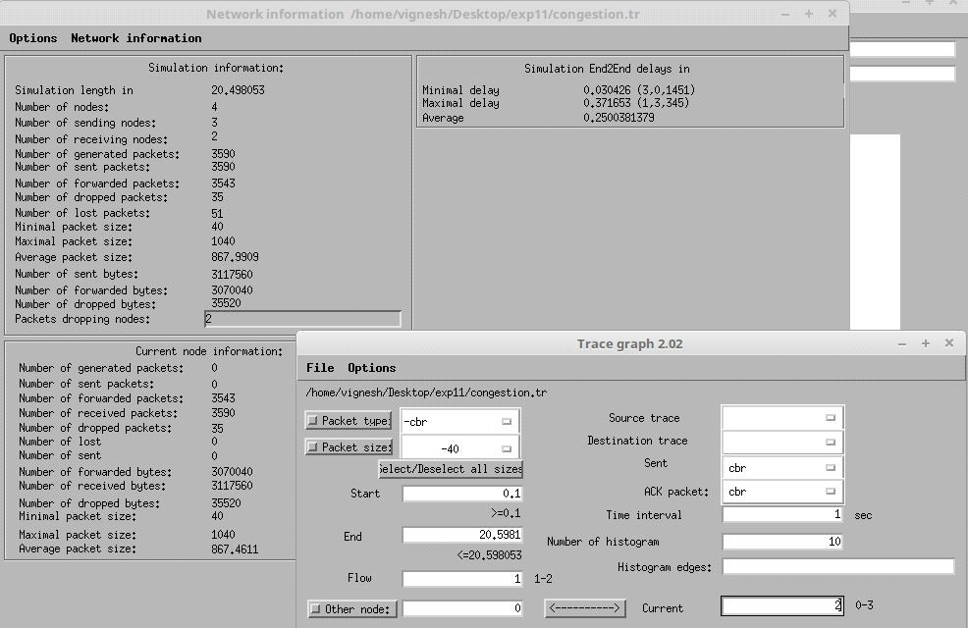

Node 2 to Node 3:

The number of received packets are 3590 which include reception from node 0 and node 1 and also receiving ACK from node 3

The number of forwarded packets is 3543 which include forwarding the received packets from node 0 and node 1 and forwarding the ACK to node 0.

**Results:** The above experiment was successfully executed, and output verified.